1. **INTRODUCTION**

Traffic signs occupy an important position in the road traffic systems. The main function of the traffic signs is to display the contents that need to be noticed in the current road sections, to prompt the drivers in front of the road the danger and difficulty in the environment, to warn the driver to drive at the prescribed speed, to provide a favorable guarantee for safe driving. Therefore, the detection and identification of traffic signs is a very important research direction, which is of great significance to prevent road traffic accidents and protect the personal safety of drivers. Road traffic signs are divided in to two major categories of main signs and auxiliary signs. The main sign is divided into warning signs, prohibition signs, mandatory signs, guide signs, tourist signs and road construction and safety signs. Among them, prohibition signs mainly played a role in banning certain kinds of behavior, a total of 43 categories. Mandatory signs indicate the role of vehicles which is placed in the need to indicate vehicles, near the intersection. Warnings are mainly to alert drivers, vehicles pedestrians to beware of dangerous targets, a total of 45 categories. They all play an important role in traffic signs. Among them, the most common speed limit signs and the prohibition of left and right turning signs are of great significance for safe driving of drivers and therefore are the focus of the current research on traffic sign recognition.

According to official statistics, about 400 road accidents occur in India every day. Road signs help to avoid accidents on the road, ensuring the safety of both drivers and pedestrians. Additionally, traffic signals guarantee that road users adhere to specific laws, minimizing the likelihood of traffic violations. Route navigation is also made easier by the use of traffic signals. Road signals should be prioritized by all road users, whether they are drivers or pedestrians. We overlook traffic signs for a variety of reasons such as problems with concentration, exhaustion, and sleep deprivation. Other causes that contribute to missing the signs include poor vision, the influence of the external world, and environmental circumstances. It is much more important to use a system that can recognize traffic signals and advise and warn the driver. Image-based traffic-sign recognition technologies analyze images captured by a car's front- facing camera in real time to recognize signals.

* 1. **Purpose**

The primary purpose of this project is to develop an intelligent vision-based system for automatic traffic sign detection and recognition to enhance road safety. The system aims to help drivers by providing real-time alerts about road signs, thereby reducing the likelihood of accidents caused by missed or ignored traffic signs. With the increasing number of vehicles on the road, traffic sign recognition becomes crucial for ensuring safe driving conditions and preventing violations. The project focuses on using deep learning techniques, specifically convolutional neural networks (CNNs) and MobileNet models, to accurately detect and classify traffic signs in real-world driving environments. By leveraging a vehicle’s front-facing camera, the system captures images of traffic signs, processes them using a trained neural network model, and provides immediate feedback to the driver. This system is particularly useful in situations where drivers may overlook signs due to fatigue, poor concentration, adverse weather conditions, or environmental distractions. Additionally, it assists drivers who may have difficulty recognizing certain road signs due to vision impairments or lack of familiarity with local regulations. The proposed solution integrates deep learning for feature extraction and classification, ensuring high accuracy and robustness even in complex and dynamic driving scenarios. The project also emphasizes efficiency, aiming to achieve real-time processing capabilities that do not compromise the performance of the vehicle’s onboard computing system. By implementing a voice-based output system, the project enhances accessibility and ensures that drivers receive alerts without diverting their attention from the road. Ultimately, the goal is to create a reliable, scalable, and adaptive system that contributes to reducing road accidents and improving traffic management through intelligent automation.

* 1. **Scope**

The scope of this project covers the development, implementation, and evaluation of a deep learning-based traffic sign recognition system that operates in real-world driving conditions. The system will be capable of detecting and identifying various categories of traffic signs, including prohibition signs, warning signs, mandatory signs, and guide signs. It will leverage CNN and Mobile Net architectures to train a robust classification model using large datasets of traffic signs collected under different environmental conditions. The system will be designed to function effectively in diverse lighting conditions, weather variations, and occlusions to ensure high reliability. Additionally, the project includes the integration of a voice- based output mechanism to alert drivers about detected signs,

making it useful for both human drivers and future autonomous vehicle systems. The implementation will focus on optimizing computational efficiency to enable real-time recognition on embedded or low-power computing devices typically used in automotive applications. The project will also explore methods to minimize false detections and misclassifications by refining model training and improving data augmentation techniques. Furthermore, the system will be evaluated using benchmark datasets and real-world testing scenarios to ensure its accuracy and robustness. The research will contribute to advancements in intelligent transportation systems by demonstrating the effectiveness of deep learning in traffic sign recognition. This project also holds potential applications in advanced driver-assistance systems (ADAS) and smart city traffic management initiatives. Future enhancements may include multi- language sign recognition, dynamic traffic condition analysis, and integration with vehicle-to-infrastructure (V2I) communication networks. The project ultimately aims to support both conventional and autonomous driving technologies by providing an efficient, scalable, and adaptive solution for real- time traffic sign recognition.

* 1. **Need For System**

### Existing System

The existing traffic sign recognition systems primarily rely on traditional image processing and machine learning techniques for detecting and classifying traffic signs. These systems generally use edge detection, color thresholding, and shape-based methods to locate traffic signs in images captured by vehicle-mounted cameras. Once detected, classification is typically performed using machine learning algorithms such as Support Vector Machines (SVMs), Random Forests, or k-Nearest Neighbors (KNN). Some systems integrate template matching techniques, where pre-defined traffic sign templates are compared with detected signs to identify them. However, these traditional methods have several limitations, including sensitivity to variations in lighting conditions, occlusions, blurriness, and environmental disturbances such as fog, rain, or shadows.

### Disadvantages

* + - * Accuracy is low
      * Time consumption is high
      * Due to low accuracy, not reliable
    1. **Proposed System**

Matrix called "Activation Map" or "Feature Map". The output layer is made up of several convolutional layers that extract features from the image. CNN can be optimized with the help of hyper parameter optimization. It finds hyper parameters of a given machine learning algorithm that deliver the best performance as measured on a validation set. Hyper parameters must be set before the learning process can begin. The learning rate and the number of units in a dense layer are provided by it. In our system will consider dropout rate, learning rate, kernel size and optimizer hyper parameter.

### Advantages

* This project is very helpful in real life we can reduce the traffic and accidents also.
  + - * VGG16 gives best accuracy compared to all the model.

**Output of Recognized Sign in Audio Format**

At present the driver will have to read the text written on the classified sign, but with the aid of a speech module, more comfort is assured. A text to speech module will alert driver with detected sign. In Python, there are many APIs available for converting text to voice. To enhance driver safety and convenience, the system incorporates a Text-to-Speech (TTS) module that provides real-time audio alerts for recognized traffic signs. Traditionally, drivers must visually interpret sign classifications displayed on a screen, which can be distracting or ineffective in certain conditions. By leveraging TTS technology, the system audibly announces the detected sign, allowing drivers to remain focused on the road. This voice-based feedback is implemented using Python-based libraries such as pyttsx3 for offline speech synthesis or gTTS for high-quality online audio generation. The integration of speech output significantly improves system accessibility, reduces cognitive load, and ensures timely awareness of critical road information.

* 1. **System Architecture**

#### Data Acquisition Layer

#### Traffic Sign Dataset Collection

* Public datasets like GTSDB, GTSRB, or custom-captured traffic sign images.
* Data includes diverse lighting, weather, and occlusion conditions.

#### Data Preprocessing Layer

#### Image Resizing & Normalization

#### Data Augmentation

* Rotation, flipping, color jittering, noise addition, etc.

#### Annotation Formatting

* Convert annotations to YOLO format (bounding boxes + class labels).

#### Model Architecture Layer

#### UCN-YOLOv5 Detection Framework

* **Backbone:** UCN (Unified Convolutional Network) for feature extraction.
* **Neck:** PANet/FPN
* **Head:** YOLOv5 Detection Head

#### Training Layer

#### Hyperparameter Configuration

* Learning rate, batch size, epochs.

#### Loss Functions

* CIoU Loss for bounding box regression.
* Cross-Entropy Loss for classification.

#### Training Pipeline

* GPU-enabled model training with validation split.
* Real-time performance monitoring using metrics like mAP and precision.

#### Inference Layer

#### Real-Time Detection

* Live video feed or image input.
* Model outputs detected traffic signs with bounding boxes and labels.

#### Alert Mechanism (Optional Enhancement)

#### Voice Feedback System

* Converts detected sign information to voice alerts for driver assistance.

#### Evaluation & Deployment Layer

#### Performance Metrics

* [mAP@0.5,](mailto:mAP@0.5) Precision, Recall, F1 Score.

#### Model Optimization

* Pruning, quantization for real-time deployment.

#### Deployment

* Integrated into an embedded system, desktop app, or mobile platform.

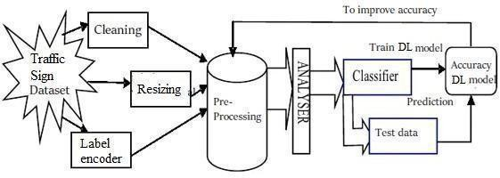

**Fig 1.4 : System Architecture Diagram**

1. **SOFTWARE REQUIREMENT ANALYSIS AND SPECIFICATION**
   1. **Product Perspective**

The proposed Traffic Sign Detection and Recognition System is an intelligent, vision- assisted solution designed to enhance road safety by providing drivers with real-time traffic sign information. It functions as a key component of an Advanced Driver- Assistance System (ADAS), utilizing deep learning techniques based on Convolutional Neural Networks (CNN) and Mobile Netarchitectures.

The system processes input from vehicle-mounted cameras to accurately detect and classify traffic signs in real time. It includes a voice-based feedback mechanism, ensuring non-intrusive, hands-free communication with the driver, thereby improving situational awareness without distraction.

Designed for robustness, the system performs reliably across a range of environmental conditions, including varying light, weather, and occlusion. Its lightweight architecture allows for efficient operation on embedded systems, making it highly compatible for integration into modern vehicles.

By delivering high accuracy, low latency, and seamless integration capabilities, the system contributes significantly to improving traffic compliance, reducing driver error, and enhancing overall road safety

* 1. **Product Function**

The Traffic Sign Detection and Recognition System functions as an intelligent, real-time assistant designed to enhance driver awareness and improve road safety. It begins by capturing continuous video streams or high-resolution images of the roadway using a vehicle-mounted camera. These visual inputs are processed using advanced deep learning techniques, specifically the UCN-YOLOv5 model architecture, which combines the feature extraction power of Unified Convolutional Networks (UCN) with the fast and accurate detection capabilities of the YOLOv5 framework. Supporting models like CNN and MobileNet are integrated to further optimize detection and classification efficiency, especially on embedded or resource-constrained systems.

Once traffic signs are detected in the frame, the system classifies them into categories such as speed limits, warnings, prohibitory signs, or directional guidance. The classification is done with high precision and in real time, ensuring that no critical road sign goes unnoticed. As soon as a traffic sign is recognized, the system activates a voice-based alert mechanism that communicates the relevant information directly to the driver. This ensures the driver receives timely and non-disruptive updates, helping maintain attention on the road while enhancing situational awareness.

Moreover, the system is designed to be robust in challenging real-world driving environments. It can operate effectively under various lighting conditions—day or night— as well as during adverse weather scenarios such as rain, fog, or glare. The architecture is optimized to handle partial occlusions, faded signs, and complex backgrounds, maintaining reliable performance across different geographical regions and road infrastructures.

The product also emphasizes practical deployability. Its compact, efficient design allows seamless integration with existing vehicle hardware and software systems, particularly within Advanced Driver-Assistance Systems (ADAS). Whether implemented in luxury vehicles or adapted for use in commercial fleets, this system enhances the vehicle's safety features without adding significant computational overhead.

* 1. **User Characteristics**

The primary users of the Traffic Sign Detection and Recognition System encompass a broad range of individuals and organizations involved in road transportation. These include everyday drivers who rely on the system for improved awareness and timely alerts about road signs, thereby enhancing their driving safety and decision-making. Commercial vehicle operators, such as truck and bus drivers, benefit from the system’s real-time voice notifications, which reduce the risk of missed traffic signs during long-distance or high- speed travel. The system is designed to be highly user-friendly, requiring minimal technical expertise. Its fully automated operation ensures that users with little to no background in technology can interact with the system effortlessly, without needing to configure or interpret complex data.

In addition to individual drivers, fleet operators and transportation agencies can integrate this solution into their vehicle management systems to monitor driver compliance with road regulations, reduce accident rates, and improve overall fleet safety. Autonomous vehicle systems can also leverage this technology as part of their sensory input and decision-making processes, enhancing their ability to understand and react to traffic environments dynamically. Furthermore, the system provides a valuable platform for researchers, developers, and academic institutions working in the fields of computer vision, intelligent transportation systems, and automotive safety, offering them a reliable and scalable framework for experimentation and innovation.

* 1. **Modules**
* Dataset preparation and preprocessing
* Featuraization
* Data splitting
* Modeling Evaluation
* Hyper parameter Tuning
* Model Testing

**Data Collection**

To effectively train and evaluate a neural network-based traffic sign recognition system, a diverse and comprehensive dataset is crucial. In this project, we utilize the German Traffic Sign Recognition Benchmark (GTSRB), a widely recognized public dataset specifically designed for traffic sign classification tasks. While Convolutional Neural Networks (CNNs) have shown remarkable performance in image analysis, their application in real-world traffic sign detection is often limited due to the lack of large-scale annotated datasets. Countries like Germany and Belgium provide high-quality datasets such as GTSRB, GTSDB, and KUL, but India lacks similarly extensive traffic sign datasets. The datasets used in our system encompass a variety of real-world conditions, including different lighting scenarios, occlusions, tilted signs, and background distractions. This diversity is essential for ensuring robust model training and evaluation.

**Data Augmentation**

Given the class imbalances in the dataset—where certain sign categories have significantly fewer examples—we implemented data augmentation techniques. These techniques included horizontal flipping and rotation, which allowed us to generate additional training samples. This strategy not only balances the dataset but also enhances the model's ability to generalize across various sign types.

**Data Splitting**

* **Validation Set:** Utilized during training, this set assists in hyperparameter tuning and ensures the model does not overfit the training data, thus maintaining its generalization capability.
* **Test Set:** This dataset remains separate until the final evaluation stage, allowing us to assess how well the trained model performs on completely new, unseen inputs.

**Feature Extraction**

Feature extraction transforms input images into numerical representations, enabling the learning algorithm to process them efficiently. Normalizing features to a similar scale also enhances training stability and accuracy. Classification With the data prepared, we apply deep learning models to classify traffic signs. Various classification techniques, including ensemble methods, are employed to improve prediction accuracy. These methods help identify patterns from complex visual inputs and can be adapted for other domains, such as medical image analysis. Classifier Training A classifier operates by taking input features and predicting a class label. Different classifiers utilize various learning methods and assumptions. In high-dimensional problems like traffic sign recognition, the number of features often exceeds the number of training samples, necessitating the use of classifiers that can manage such conditions without overfitting.

**CNN Architecture Components**

* Convolutional Layer: Detects visual patterns in input images by sliding learnable filters across them.
* Pooling Layer: Reduces the spatial dimensions of feature maps while preserving relevant information, decreasing computational load, and enhancing model robustness to input variations.
* ReLU Activation: Applies a non-linear function that replaces negative values in the feature map with zero, introducing non-linearity into the model.
* Fully Connected Layer: Connects all neurons from the previous layer to the next, aiding in classification based on extracted features and serving as the final decision-making component.

**Phases of Model Development**

* Model Construction: Building the CNN architecture with layers suited to the task.
* Model Training: The model learns from the training data by adjusting weights through backpropagation.
* Model Evaluation: This stage assesses the model's performance using key metrics such as accuracy, precision, recall, and F1-score, providing a comprehensive view of its strengths and weaknesses.

**Mobile Net**

Mobile Net, developed by Google, is designed for lightweight applications where computational resources are limited, such as mobile and embedded systems Despite having fewer parameters, Mobile Net achieves fast inference times and reasonable accuracy. It categorizes extracted image features into low-level, mid-level, and high-level representations and is trained on over 13,000 annotated images for traffic sign detection.

**Res Net and Its Variants**

Res Net (Residual Network) is a powerful deep learning model that incorporates skip connections, allowing certain layers to bypass others.

* Highway Nets: Introduce single or multiple skip connections with additional weight matrices.
* Dense Nets: Feature multiple parallel skip paths connecting all layers, enhancing information flow.
* ResNet supports both forward and backward propagation through these paths, improving error correction during training.

**Dataset Preparation and Preprocessing**

The Dataset Preparation and Preprocessing Module is vital in developing any machine learning or deep learning system. The dataset primarily consists of labeled traffic sign images collected from publicly available sources, such as the GTSRB or custom datasets captured in real-time environments.

**Key Steps:**

* Data Collection: Ensuring diversity in lighting conditions, angles, backgrounds, and weather to enhance model robustness.
* Data Cleaning: Removing duplicate, irrelevant, or corrupted images.
* Data Augmentation: Techniques such as rotation, zooming, flipping.
* Normalization: Pixel values are normalized.
* Label Encoding: Categorical class labels (e.g., “Stop”, “Speed Limit”, “Yield”) are converted into numerical format using one-hot encoding or label encoding, making them compatible with the model’s output layer.

**Dataset Splitting: The processed dataset is divided into:**

• Training set: ~70–80% of the data

• Validation set: ~10–15% for tuning hyperparameters

* Test set: ~10–15% for final evaluation, helping assess the model's generalization ability on unseen data.

**Featurization**

Featurization is a crucial stage in the machine learning and deep learning pipeline where raw input data is transformed into a structured representation of meaningful characteristics, known as features, that can be effectively understood and learned by models. In the context of traffic sign recognition using CNNs, featurization is automatically handled by the convolutional layers of the network. Unlike traditional machine learning, where hand-crafted features are extracted (e.g., HOG, SIFT), CNNs learn hierarchical feature representations directly from image data through training.

**How Featurization Works in CNNs:**

* Convolutional Layers: Apply filters (kernels) to input images to detect patterns
* such as edges, curves, textures, and shapes, resulting in feature maps that highlight specific patterns in various spatial locations of the image.
* Activation Functions: Non-linear activation functions like ReLU are applied post-convolution to introduce non-linearity and help the model learn complex relationships.
* Deeper Feature Extraction: As images pass through multiple convolutional and pooling layers, the model learns increasingly abstract and high-level features, such as the overall shape of a stop sign or the structure of speed limit digits.
* Flattening and Dense Layers: Integrate the extracted features and make the final classification decision.

**Data Splitting**

Dividing a dataset into different portions is a key step in training and evaluating any deep learning or machine learning model. This process ensures that the model is trained properly, tuned effectively, and evaluated fairly on unseen data.

**Types of Data Splits:**

* Training Set: Enables the model to learn patterns and update its internal weights accordingly, laying the groundwork for accurate predictions.
* Validation Set: Used during training to adjust and optimize hyperparameters, typically comprising around 10% to 15% of the dataset.
* Test Set: Completely unseen by the model during training and validation phases, this dataset is kept isolated to ensure an unbiased evaluation, typically comprising about 10% to 15% of the total dataset.

**Purpose of Evaluation:**

• Assess the model’s predictive accuracy.

• Detect and address underfitting or overfitting.

• Compare different models or configurations for performance.

• Use standardized metrics to measure success.

**Evaluation Metrics Used:**

For traffic sign classification, the following metrics are considered essential:

* **Accuracy:** The percentage of correctly classified traffic signs among total predictions, ideal for balanced datasets.
* **F1 Score:** Useful when dealing with class imbalance.
* **Confusion Matrix:** Displays actual vs. predicted classifications for each class, helping identify frequently misclassified classes.

**Hyperparameter Tuning**

Hyperparameters are externally defined configurations that shape how a machine

learning model is built and how it learns from data.

**Key Hyperparameters:**

* **Number of Epochs:** Indicates how many times the entire training data is passed through the model.
* **Optimizer Type:** The optimization algorithm (e.g., Adam, SGD, RMSprop) that adjusts the weights to minimize prediction error.

**Hyperparameter Tuning in Our System**

In our traffic sign recognition model built using a CNN architecture (such as UCN-YOLOv5), hyperparameter tuning was essential for maximizing accuracy and generalization. The following parameters were fine-tuned:

* + **Kernel Size:** Altered to better capture patterns in signs of various shapes and sizes.
  + **Optimizer:** Both Adam and SGD were tested to determine the most effective option for our task.
  + **Epochs and Batch Size:** Balanced to maintain computational efficiency and model performance.

**Tuning Techniques Applied**

We employed various approaches to identify the most effective hyperparameter combinations:

* **Random Search:** Sampled random combinations to efficiently cover a broader space.
* **Automated Tools (optional):** Tools like Keras Tuner or Optuna were considered for intelligent, automated searches.

**Why Hyperparameter Optimization Matters**

Optimizing hyperparameters offers several advantages:

• Enhances overall model accuracy and consistency.

• Improves training speed and resource efficiency.

* 1. **Functional and Non-Functional Requirements**

### Functional Requirements

The traffic sign recognition system must be capable of detecting and identifying traffic signs in real-time using images captured from a vehicle's front-facing camera. It should accurately classify different categories of traffic signs, such as warning signs, prohibition signs, and mandatory signs, using deep learning models like CNN and MobileNet. The system must preprocess images, including resizing, noise reduction, and contrast enhancement, to improve detection accuracy.

It should provide an alert mechanism, such as voice output, to notify drivers about detected signs without distracting them. The system should support real-time processing to ensure timely recognition while the vehicle is in motion. It must be able to handle environmental variations such as different lighting conditions, weather changes, and occlusions to ensure reliable performance. The application should have a user- friendly interface for configuration and monitoring. Additionally, the system should allow periodic model updates to improve accuracy based on new training data. It should be capable of operating on embedded or low-power

computing devices commonly used in automotive applications. The system must log detected traffic signs for further analysis, which can be useful for traffic management and accident prevention studies.

### Non-Functional Requirements

The system should be highly efficient to ensure minimal delay in traffic sign recognition and alert generation. It must be robust and reliable, maintaining consistent performance under different environmental and road conditions. The accuracy of sign detection and classification should meet industry standards to minimize false positives and false negatives. The system should be scalable, allowing the integration of additional features like multilingual sign recognition or integration with vehicle-to-infrastructure (V2I) communication. It should have low computational overhead to ensure smooth performance on real-time embedded systems without excessive power consumption.

The user interface should be intuitive and accessible, providing easy configuration and monitoring options for users. The system should be designed with modularity in mind, allowing future enhancements and updates without major architectural changes. Security measures should be in place to prevent unauthorized access or tampering with the recognition system. The application should be compatible with different camera types and hardware platforms to support a wide range of vehicle models. Lastly, the system should adhere to industry safety and compliance regulations to ensure its reliability in real-world driving scenarios.

* 1. **System specifications**

### Software Requirements

IDE : Anaconda Jupiter Programming Language : Python

### Hardware requirements

Processor : Dual Core 2 Duos.

RAM : 4 GB DD RAM

Hard Disk : 250 GB

* 1. **Software Development Life Cycle**

Software development life cycle (SDLC) is a structured process that is used to design, develop, and test good-quality software. SDLC, or software development life cycle, is a methodology that defines the entire procedure of software development step-by-step. The goal of the SDLC life cycle modelis to deliver high-quality, maintainable software that meets the user’s requirements. SDLC in software engineering models outlines the plan for each stage so that each stage of the software development model can perform its task efficiently to deliver the software at a low cost within a given time frame that meets users requirements. In this article we will see Software Development Life Cycle (SDLC) in detail.

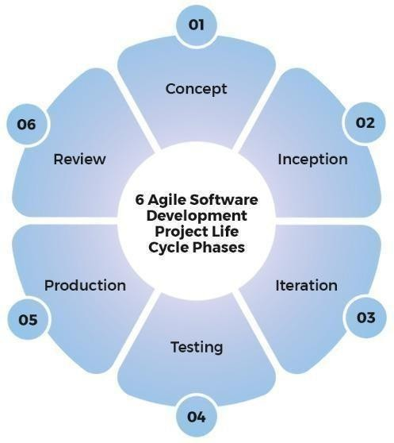The Waterfall Model is a sequential software development approach where each phase must be completed before moving to the next. It includes requirement analysis, system design, implementation, testing, deployment, and maintenance. This model is best suited for projects with well-defined requirements, ensuring a structured and predictable development process.

**Fig 2.7 : Software Development Life Cycle**

#### Waterfall Model

The Waterfall Modelis one of the earliest and most traditional software development life cycle (SDLC)models. It's a linear and sequentialapproach where progress flows steadily downwards like a waterfall through various phases.

Waterfall Modelby progressing through a series of well-defined phases. In the requirement analysisphase, the objectives were set—to build a deep learning model capable of accurately detecting traffic signs in real-time and issuing voice-based alerts. During the system designphase, the architecture was planned using the YOLOv5 model enhanced with UCN (Up sample-Concatenate-Normalization) modifications, and decisions were made regarding dataset selection, hardware requirements, and system components. In the implementationphase, the model was trained using annotated datasets, and the object detection system was developed with preprocessing, training, and integration of voice alerts. The testing phase involved evaluating the model's performance under various environmental conditions and measuring accuracy, precision, and robustness. Following successful testing, the system was deployedon a real-time platform, allowing it to process live camera input and provide audio alerts for detected traffic signs. Finally, in the maintenance phase, updates and optimizations were planned to improve performance, add new sign classes, and ensure long-term reliability. This structured, step-by-step approach ensured clear progress and minimized risks throughout the development process.

#### Phases of the Waterfall Model

#### Requirement Analysis

* + All requirements are gathered and documented.
  + No development starts until all requirements are clearly defined.

#### System Design

* + Based on the requirements, system architecture and design are prepared.
  + Includes hardware/software specifications and data flow design.

#### Implementation (Coding)

* + Developers write code based on the design documents.

#### Testing

* + The system is tested for bugs and errors.
  + Verification is done to ensure the software meets the requirements.

#### Deployment

* + The product is released and deployed for end users.

#### Maintenance

* + Ongoing support and updates after the product is delivered.

#### Advantages

* Simple to clarify for the clients.
* Structures approach.
* Stages and exercises are distinct.
* 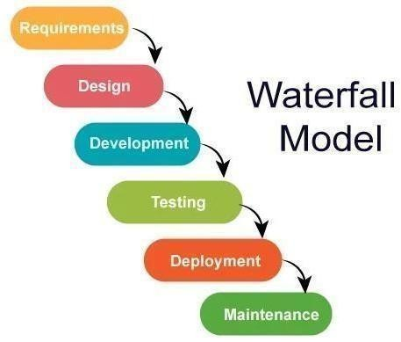Assists with arranging and timetable the task.

**Fig 2.7.1 : Waterfall Model Diagram**

* 1. **System Study**

The proposed system aims to develop a traffic sign detection and recognition model for automatic driving car systems using deep learning. The system captures real-time road images, detects traffic signs, classifies them, and provides the output through voice assistance. The primary objective is to enhance road safety by reducing driver dependence and ensuring adherence to traffic regulations. With the increasing number of vehicles on the road, traffic sign recognition has become a critical component of autonomous driving technology. By automating traffic sign detection, the system minimizes human error, enhances navigation, and ensures compliance with traffic laws.

#### Feasibility Study

The feasibility study evaluates the viability of the proposed system from different perspectives, including technical, economic, and social aspects. The analysis ensures that the system is practical, cost-effective, and beneficial to society.

#### Technical Feasibility

This aspect examines whether the system can be developed using existing technology. The required hardware includes a high-performance GPU for training deep learning models, a vehicle-mounted camera for real-time image capture, and a microcontroller with a speaker for voice output. The software stack includes Python, TensorFlow/Keras for deep learning, OpenCV for image processing, and pre-trained models such as YOLOv5 and VGG16. Challenges in technical feasibility include real-time image processing with minimal latency, handling varying environmental conditions, and ensuring accurate voice output.

#### Economic Feasibility

This evaluates the cost-effectiveness of implementing the system. Development costs include expenses for software tools, training datasets, and computing resources. Hardware costs involve purchasing high-resolution cameras, GPUs, and integrating components into

vehicles. Operational costs are minimal as the system runs on pre-trained models, reducing the need for extensive computational resources. A cost-benefit analysis shows that the system’s benefits—improved traffic safety, reduced accident rates, and enhanced vehicle automation—justify its implementation cost.

#### Social Feasibility

This assesses the impact of the system on society and user acceptance. The system enhances safety by providing real-time traffic sign information to drivers, thereby reducing accidents. It supports user adoption by integrating seamlessly into autonomous and semi- autonomous vehicles, making driving safer and more efficient. Regulatory compliance is strengthened as the system ensures accurate recognition of traffic signs, aiding in law enforcement and traffic management.

* 1. **Methodology and Algorithms**

The traffic sign recognition system follows a structured methodology to ensure accurate and efficient detection. The process begins with image acquisition, where real-time road images are captured using a front-facing vehicle camera.

These images then undergo preprocessing, including resizing, noise reduction, contrast enhancement, and normalization, to standardize the input for further analysis. Next, in the traffic sign detection phase, deep learning models such as convolutional neural networks and Mobile net are used to locate traffic signs in the captured images by identifying the region of interest. Once detected, the system proceeds with feature extraction, where the neural network automatically learns key traffic sign characteristics such as color, shape, and texture, eliminating the need for manual feature engineering.

Following detection, the traffic sign classification phase classifies the detected sign into predefined categories such as warning signs, prohibition signs, and mandatory signs using the trained convolutional neural network model. The prediction and output generation step then provides the recognized traffic sign's result, which is displayed visually and communicated through a voice alert, ensuring the driver receives the information without distraction. The model undergoes training and optimization using large datasets of labeled traffic sign images, incorporating techniques like data augmentation, dropout, and batch normalization to improve accuracy and generalization. After training, the system is subjected to testing and validation using real- world images to assess its robustness against variations in lighting, occlusions, and environmental disturbances.

The final step involves real-time implementation, where the optimized model is deployed on an embedded system or vehicle-mounted computing device to ensure smooth and efficient performance during driving.

### Algorithms

**Convolutional Neural Networks (CNN)** – CNNs are used for feature extraction and classification of traffic signs. They automatically learn spatial hierarchies of features, making them highly effective for image-based tasks like traffic sign recognition.

#### Key Components of CNN

#### Input Layer

* + Takes in an image (e.g., 224x224 pixels with 3 color channels for RGB).

#### Convolutional Layer (Conv Layer)

* + Applies filters (also called kernels) to extract featureslike edges, corners, textures.
  + Each filter scans the image and creates a feature map.

Feature Map=Image∗Kernel\text{Feature Map} = \text{Image} *

\text{Kernel}Feature Map=Image∗Kernel

#### Activation Function (ReLU)

* + Applies non-linearity so the network can learn complex patterns.
  + Example: ReLU (Rectified Linear Unit) converts negative values to zero.

#### Pooling Layer (Subsampling)

* + Reduces the spatial size of the feature maps.
  + **Max Pooling** picks the maximum value in a region to retain important features.

#### Fully Connected Layer (FC Layer)

* + Connects all neurons from the last layer to classify the image.
  + Works like a traditional neural network.

#### Output Layer

* + Produces final predictions (e.g., classifying if the image is a “Stop” sign or “Speed Limit”).

#### How CNN Works – Step-by-Step Flow

* **Input** an image (e.g., a traffic sign).
* **Convolution** detects low-level features (edges, lines).
* **Deeper Convolutions** detect complex features (shapes, patterns).
* **Pooling** reduces dimensions and computations.
* **Fully Connected Layer** interprets features.
* **Output Layer** gives final classification (e.g., “Speed Limit 50”).

#### Why CNN Is Used in My Project

In my project (UCN-YOLOv5: Traffic Sign Object Detection), CNN is the core architectureused within YOLOv5. It helps automatically extract visual features from traffic sign images, enabling the model to detect and classify them accurately in real time.

**Mobile Net** – This is a lightweight deep learning model optimized for real-time image classification on mobile and embedded devices. It helps in efficient traffic sign detection while maintaining high accuracy and low computational cost.

#### Key Concepts in Mobile Net

#### Depth wise Separable Convolutions (Core Innovation)

* + Depth wise Convolution
  + Pointwise Convolution (1x1 Convolution**) Mobile Net in My Project**

In my project, Mobile Net can be used as a lightweight feature extractorfor detecting traffic signs in real-time, especially on devices with limited resources like mobile phones, Raspberry Pi, or Jetson Nano. It ensures faster inference and lower power consumption, making it ideal for real-world deployment.

* 1. **Technology Used**

Technology Used The implementation of Traffic Sign Prediction for Automatic Driving Car System Using Deep Learning relies on advanced deep learning frameworks and models.

* **Deep Learning Frameworks:** TensorFlow, PyTorch
* **Models:** CNN, MobileNet
* **Image Processing:** OpenCV
* **User Interface:** Streamlit, Flask
* **Hardware:** GPU for fast computations
* **Voice Alerts:** Text-to-Speech (TTS) libraries Below is a brief explanation of the technologies used
* **Deep Learning Frameworks**: Deep learning frameworks provide the necessary tools and libraries to develop and train deep neural networks efficiently.
  + **TensorFlow:** TensorFlow is an open-source deep learning framework developed by Google. It supports end-to-end machine learning workflows, including neural network training and deployment. Features Keras API, which simplifies building deep learning models. Provides GPU and TPU acceleration, enabling efficient training of deep learning

models. Used for tasks like image processing, object detection, and speech recognition.

* + **PyTorch:** PyTorch is an open-source deep learning framework developed by Facebook (Meta). It provides dynamic computational graphs, making it easier to debug and modify models. Supports automatic differentiation for optimizing neural networks. Commonly used in computer vision, NLP (Natural Language Processing), and deep learning research.
  + **Deep Learning Models:** Deep learning models are used to process images, detect objects, and classify traffic signs.
  + Convolutional Neural Networks (CNN) are specialized deep learning models designed for image processing and computer vision tasks. They consist of convolutional layers, pooling layers, and fully connected layers. CNNs extract important features from images, making them ideal for traffic sign recognition. They are robust to variations in lighting, perspective, and occlusions.
  + Mobile Net is a lightweight deep learning model designed for mobile and embedded vision applications. Uses depth wise separable convolutions, reducing computation while maintaining high accuracy. Optimized for low- power and real-time processing, making it suitable for autonomous driving systems. Provides fast inference speed, allowing quick traffic sign detection and recognition.

**Python:** Python is currently the most widely used multi-purpose, high- level programming language. Python allows programming in Object- Oriented and Procedural paradigms. Python programs generally are smaller than other programming languages like Java.

#### History of Python Programming Language

* **Introduction** Python is a high-level, interpreted programming language known for its simplicity and versatility. It supports multiple programming paradigms, including procedural, object-oriented, and functional programming. Due to its readability and vast library support, Python has become a language of choice in diverse domains such as web development, data science, artificial intelligence, automation, and scientific computing.
* **Origin and Development** Python was created by Guido van Rossum in the late 1980s as a successor to the ABC programming language. The first official version, Python 1.0, was released in January 1994. Van Rossum aimed to design a language that emphasized code readability and developer productivity. Python is an open-source language, with development managed by the Python Software Foundation (PSF).
* **Naming of Python** The name "Python" was inspired not by the snake, but by the British comedy television series "Monty Python's Flying Circus." Guido van Rossum was a fan of the show and wanted a name that was unique, short, and slightly mysterious.

#### Evolution of Python Versions

**Python 1.x (1991–2000)** Python 1.0 laid the foundation with features such as functions, exception handling, and core data types like lists, dictionaries, and strings.

**Python 2.x (2000–2010)** Released in 2000, Python 2.x introduced major features such as list comprehensions, garbage collection, and better support for Unicode. Python 2.7, the last in the 2.x line, remained in use for a long time but reached its end of life on January 1, 2020.

**Python 3.x (2008–Present)** Python 3.0, released in December 2008, was a major upgrade that broke backward compatibility to address fundamental design flaws. It introduced improvements such as:

* + print() as a function
  + Full Unicode support
  + Advanced data handling features
  + Syntax enhancements like f-strings and async/await
  + **Rise in Popularity and Applications** Python's popularity surged due to its minimalistic syntax and robust libraries. It is extensively used in:
* **Web Development** (Django, Flask)
* **Data Science & AI** (NumPy, pandas, scikit-learn, TensorFlow, PyTorch)

#### Automation & Scripting

* **Game Development** (Pygame)
* **Embedded Systems** (MicroPython)

Python consistently ranks among the top programming languages in indices such as TIOBE and the Stack Overflow Developer Survey.

* **Python in Modern Computing** Python's dominance in AI and machine learning is especially notable. Its frameworks allow researchers and developers to build complex models efficiently. It is also a go-to language in academia for teaching programming fundamentals.
* **Community and Future Prospects** Managed by the Python Software Foundation, Python enjoys vibrant community support. Regular updates, strong documentation, and active forums contribute to its growth. With the advent of Python 3.12 and beyond, the language continues to evolve, focusing on performance, simplicity, and developer experience.

#### Advantages :

* + **Easy to Learn and Use**: Python has a simple and clean syntax, making it ideal for beginners.
  + **Versatile and High-Level**: Suitable for web development, automation, data analysis, AI, and more.
  + **Extensive Libraries and Frameworks**: Rich ecosystem for scientific computing, machine learning, and development.
  + **Strong Community Support**: Active developer community with abundant resources and documentation.
  + **Cross-Platform Compatibility**: Python code can run on various operating systems without modification.
  + **Rapid Development and Prototyping**: Encourages quick experimentation and iteration.

#### Disadvantages :

* + **Slower Execution Speed**: Interpreted nature makes Python slower than compiled languages like C or C++.
  + **High Memory Usage**: Not ideal for memory-intensive tasks, especially in constrained environments.
  + **Mobile Development Limitations**: Less commonly used for mobile app development.
  +  **Runtime Errors**: Python is dynamically typed, which may lead to unexpected bugs at runtime.
  + **Not Ideal for Low-Level Programming**: Python is abstracted from hardware and lacks low-level capabilities like manual memory management.

### Standard Data Types

The data stored in memory can be of many types. For example, a person's age is stored as a numeric value and his or her address is stored as alphanumeric characters. Python has various standard data types that are used to define the operations possible on them and the storage method for each of them.

Python has five standard data types –

* + Numbers
  + String
  + List
  + Tuple
  + Dictionary

#### Python Numbers

Number data types store numeric values. Number objects are created when you assign a value to them.

#### Python Strings

Strings in Python are identified as a contiguous set of characters represented in

the quotation marks. Python allows for either pairs of single or double quotes.

Subsets of strings can be taken using the slice operator ([ ] and [:]) with indexes

starting at 0 in the beginning of the string and working their way from -1 at the

end.

#### Python Lists

Lists are the most versatile of Python's compound data types. A list contains items separated by commas and enclosed within square brackets ([]). To some extent, lists are similar to arrays in C. One difference between them is that all the items belonging to a list can be of different data type.

The values stored in a list can be accessed using the slice operator ([ ] and [:]) with indexes starting at 0 in the beginning of the list and working their way to end -1. The plus (+) sign is the list concatenation operator, and the asterisk (*) is the repetition operator.

#### Python Tuples

A tuple is another sequence data type that is similar to the list. A tuple consists of a number of values separated by commas. Unlike lists, however, tuples are enclosed within parentheses.

The main differences between lists and tuples are: Lists are enclosed in brackets ([ ]) and their elements and size can be changed, while tuples are enclosed in parentheses (()) and cannot be updated. Tuples can be thought of as read-only lists.

#### Python Dictionary

Python's dictionaries are kind of hash table type. They work like associative arrays or hashes found in Perl and consist of key-value pairs. A dictionary key can be almost any Python type, but are usually numbers or strings. Values, on the other hand, can be any arbitrary Python object.

Dictionaries are enclosed by curly braces ({ }) and values can be assigned and accessed using square braces ([]).

Different modes in python Python has two basic modes:

* + Normal
  + Interactive

The normal mode is the mode where the scripted and finished .pie files are run in the Python interpreter.Interactive mode is a command line shell which gives immediate feedback for each statement, while running previously fed statements in active memory. As new lines are fed into the interpreter, the fed program is evaluated both in part and in whole.

### Python Libraries

* **Requests:** The most famous http library written by Kenneth remits. It’s a must have for every python developer.
* **Scrappy:** If you are involved in web scraping then this is a must have library for you. After using this library you won’t use any other.
* **Python.** A GUI toolkit for python. primarily used it in place of tinder.
* **Pillow.** A friendly fork of PIL (Python Imaging Library). It is more user friendly t than PIL and is a must have for anyone who works with images.
* **SQL Alchemy.** A database library.
* **Beautiful Soup I**t’s slow but this xml and html parsing library is very useful for beginners.
* **Twisted.** The most important tool for any network application developer. It has a very beautiful ape and is used by a lot of famous python developers.
* **Numbly.** It provides some advance math functionalities to python.
* **Skippy.** It is a library of algorithms and mathematical tools for python and has caused many scientists to switch from ruby to python.
* **Matplotlib.** A numerical plotting library. It is very useful for any data scientist or any data analyser.
* **Pygmy**. Which developer does not like to play games and develop them?
* **Piglet.** A 3d animation and game creation engine. This is the engine in which the famous [python port](https://github.com/fogleman/Minecraft) of mine craft was made
* **Pit.** A GUI toolkit for python. It is my second choice after python for developing GUI’s for my python scripts.
* **Pit.** Another python GUI library. It is the same library in which the famous Bit torrent client is created.
* **Scaly.** A packet sniffer and analyser for python made in python.
* **Pywin32.** A python library which provides some useful methods and classes for interacting with windows.
* **Notch.** Natural Language Toolkit – I realize most people won’t be using this one, but it’s generic enough. It is a very useful library if you want to manipulate strings. But its capacity is beyond that. Do check it out.
* **Nose.** A testing framework for python. It is used by millions of python developers. It is a must have if you do test driven development.
* **Simply.** Simply can-do algebraic evaluation, differentiation, expansion, complex numbers, etc. It is contained in a pure Python distribution
* **I Python.** I just can’t stress enough how useful this tool is. It is a python prompt on steroids. It has completion, history, shell capabilities, and a lot more. Make sure that you take a look at it.

#### NumPy

Humpy’s main object is the homogeneous multidimensional array. It is a table of elements (usually numbers), all of the same type, indexed by a tuple of positive integers. In numbly dimensions are called axes. The number of axes is rank.

* Offers Matlab-ish capabilities within Python
* Fast array operations
* 2D arrays, multi-D arrays, linear algebra etc.

#### Matplotlib

* High quality plotting library.

#### Python class and objects

These are the building blocks of OOP. Class creates a new object. This object can be anything, whether an abstract data concept or a model of a physical object, e.g. a chair. Each class has individual characteristics unique to that class, including variables and methods. Classes are very powerful and currently “the big thing” in most programming languages. The class is the most basic component of object-oriented programming. Objects are an encapsulation of variables and functions into a single entity. Objects get their variables and functions from classes. Classes are essentially a template to create objects.

#### A brief list of Python OOP ideas:

* + The class statement creates a class object and gives it a name. This creates a new namespace.
  + Assignments within the class create class attributes. These attributes are accessed by qualifying the name using dot syntax: Class Name Attribute.
  + Class attributes export the state of an object and its associated behaviour. These attributes are shared by all instances of a class
  + Calling a class (just like a function) creates a new instance of the class.
  + This is where the multiple copy’s part comes in.
  + Each instance gets ("inherits") the default class attributes and gets its own namespace. This prevents instance objects from overlapping and confusing the program.

### Inheritance

Classes allow you to modify a program without really making changes to it. To elaborate, by sub classing a class, you can change the behaviour of the program by simply adding new components to it rather than rewriting the existing components. Classes can also inherit attributes from other classes. Hence, a subclass inherits from a superclass allowing you to make a generic superclass that is specialized via subclasses. The subclasses can override the logic in a superclass, allowing you to change the behaviour of classes without changing the superclass at all.

#### Operator Overloads

Operator overloading simply means that objects that you create from classes can respond to actions (operations) that are already defined within Python, such as addition, slicing, printing, etc.

Even though these actions can be implemented via class methods, using overloading ties the behaviour closer to Python’s object model and the object interfaces are more consistent to Python’s built-in objects, hence overloading is easier to learn and use. User-made classes can override nearly all of Python’s built-in operation methods

### Exceptions

Exceptions are events that modify program’s flow, either intentionally or due to errors. They are special events that can occur due to an error, e.g. trying to open a file that doesn’t exist, or when the program reaches a marker, such as the completion of a loop.

Exceptions, by definition, don’t occur very often; hence, they are the "exception to the rule" and a special class has been created for them. Exceptions are everywhere in Python. Virtually every module in the standard Python library uses them, and Python itself will raise them in a lot of different circumstances.

Here are just a few examples:

* Accessing a non−existent dictionary key will raise a Key Error exception.
* Searching a list for a non−existent value will raise a Value Error exception
* Calling a non−existent method will raise an Attribute Error exception.
* Referencing a non−existent variable will raise a Name Error exception.
* Mixing data types without coercion will raise a Type Error exception.

User-Defined Exceptions

Python does allow for a programmer to create his own exceptions.

However, before making own exceptions, make sure there isn’t one of the built-in exceptions that will work for you. They have been "tested by fire" over the years and not only work effectively, they have been optimized for performance and are bug- free. Making own exceptions involves object-oriented programming, which will be covered in the next chapter To make a custom exception, the programmer determines which base exception to use as the class to inherit from, e.g. making an exception for negative numbers or one for imaginary numbers would probably fall under the Arithmetic Error exception class. To make a custom exception, simply inherit the base exception and define what it will do. Python modules Python allows us to store our code in files (also called modules). This is very useful for more serious programming, where we do not want to retype a long function definition from the very beginning just to change one mistake. In doing this, we are essentially defining our own modules, just like the modules defined already in the Python library. To support this, Python has a way to put definitions in a file and use them in a script or in an interactive instance of the interpreter. Such a file is called a module; definitions from a module can be imported into other modules or into the main module.

#### Testing code

To test the code, import it into a Python session and try to run it. Usually there is an error, so you go back to the file, make a correction, and test again. This process is repeated until you are satisfied that the code works. There are two types of errors that you will encounter.

Syntax errors occur when the form of some command is invalid. This happens when you make typing errors such as misspellings, or call something by the wrong name, and for many other reasons. Python will always give an error message for a syntax error.

#### Functions in Python

It is possible, and very useful, to define our own functions in Python. Generally speaking, if you need to do a calculation only once, then use the interpreter. But when you or others have need to perform a certain type of calculation many times, then define a function.

You use functions in programming to bundle a set of instructions that you want to use repeatedly or that, because of their complexity, are better self-contained in a sub-program and called when needed.

There are three types of functions in python

* Help ()
* min ()
* print ().

Namespaces in Python are implemented as Python dictionaries, this means it is a mapping from names (keys) to objects (values). The user doesn't have to know this to write a Python program and when using namespaces.

Some namespaces in Python

* global names of a module
* local names in a function or method invocation
* built-in names: this namespace contains built-in functions (e.g. abs(), camp(), ...) and built-in exception names

### Garbage Collection

Garbage Collector exposes the underlying memory management mechanism of Python, the automatic garbage collector. The module includes functions for controlling how the collector operates and to examine the objects known to the system, either pending collection or stuck in reference cycles and unable to be freed.

### Python Xml Parser

XML is a portable, open source language that allows programmers to develop applications that can be read by other applications, regardless of operating system and/or developmental language. he Extensible Markup Language XML is a

markup language much like HTML or SGML. This is recommended by the World Wide Web Consortium and available as an open standard. XML is extremely useful for keeping track of small to medium amounts of data without requiring a SQL-based backbone.

XML Parser Architectures and APIs the Python standard library provides a minimal but useful set of interfaces to work with XML.The two most basic and broadly used APIs to XML data are the

* SAX
* DOM interfaces.

**Simple API for XML SAX**: Here, you register callbacks for events of interest and then let the parser proceed through the document.This is useful when documents are large or you have memory limitations, it parses the file as it reads it from disk and the entire file is never stored in memory.

**Document Object Model DOM API** : This is a World Wide Web Consortium recommendation wherein the entire file is read into memory and stored in a hierarchical tree − based form to represent all the features of an XML document.

Python Web Frameworks A web framework is a code library that makes a developer's life easier when building reliable, scalable and maintainable web applications. Web frameworks encapsulate what developers have learned over the past twenty years while programming sites and applications for the web. Frameworks make it easier to reuse code for common HTTP operations and to structure projects so other developers with knowledge of the framework can quickly build and maintain the application. Frameworks provide functionality in their code or through extensions to perform common operations required to run web applications.

These common operations include:

* URL routing
* HTML, XML, JSON, and other output format tinplating
* Database manipulation
* Security against Cross-site request forgery (CSRF) and other attacks
* Session storage and retrieval

Not all web frameworks include code for all of the above functionality. Frameworks fall on the spectrum from executing a single use case to providing every known web framework feature to every developer. Some frameworks take the "batteries- included" approach where everything possible comes bundled with the framework while others have a minimal core package that is amenable to extensions provided by other packages. Comparing web frameworks There is also a repository called [compare-python-web-](https://github.com/mattmakai/compare-python-web-frameworks) [frameworks](https://github.com/mattmakai/compare-python-web-frameworks) where the same web application is being coded with varying Python web frameworks, tinplating engines and object.

* When you are learning how to use one or more web frameworks it's helpful to have an idea of what the code under the covers is doing.
* Frameworks is a really well done short video that explains how to choose between web frameworks. The author has some particular opinions about what should be in a framework. For the most part I agree although I've found sessions and database ORMs to be a helpful part of a framework when done well.
* What is a web framework? Is an in-depth explanation of what web frameworks are and their relation to web servers?
* Jingo vs. Flash vs. Pyramid: Choosing a Python web framework contains background information and code comparisons for similar web applications built in these three big Python frameworks.
* This fascinating blog post takes a look at the code complexity of several Python web frameworks by providing visualizations based on their code bases.
* Python’s web frameworks benchmarks is a test of the responsiveness of a framework with encoding an object to JSON and returning it as a response as well as retrieving data from the database and rendering it in a template. There were no conclusive results but the output is fun to read about nonetheless.
* What web frameworks do you use and why are they awesome? Is a language agnostic Reedit discussion on web frameworks? It's interesting to see what programmers in other languages like and dislike about their suite of web frameworks compared to the main Python frameworks.
* This user-voted question & answer site asked "What are the best general purpose Python web frameworks usable in production?” The votes aren't as important as the list of the many frameworks that are available to Python developers.

#### Web frameworks learning checklist

* Choose a major Python web framework (Jingo or Flask are recommended) and stick with it. When you're just starting it's best to learn one framework first instead of bouncing around trying to understand every framework.
* Work through a detailed tutorial found within the resources links on the framework's page.
* Study open-source examples built with framework of choice so you can take parts of those projects and reuse the code in application.
* Build the first simple iteration of web application then go to the [deployment](https://www.fullstackpython.com/deployment.html) section to make it accessible on the web.

# SYSTEM DESIGN

Designing of system is the process in which it is used to define the interface, modules and data for a system to specified the demand to satisfy. System design is seen as the application of the system theory. The main thing of the design a system is to develop the system architecture by giving the data and information that is necessary for the implementation of a system.

* 1. **Entity Relationship Diagram**

Entity relationship analysis leverages three basic abstractions to characterize data. Entities (distinctive things in the firm), Relationships (meaningful interactions between objects), and Attributes (entity and relationship properties). The entity Relationship Diagram (ERD) illustrates the relationship between data objects. The ERD is the notation used to do the date modelling activity. Each data object specified in the ERD has detailed attributes that can be defined. The primary function of the ERD is to represent data objects and their relationships. This diagramming technique's relative simplicity and pictorial clarity may explain why the ER model is so widely used. A conceptual ER-Diagram is used to structure the relationship to the system, which specifies not only the existential entities but

also the standard relations via.

#### ER Diagram Components

Rectangle, it represents the entity set.

llipse, it represents attributes.

Diamond, it represents relationship sets.

Double Ellipse represents Multi value attributes.



### Entity

* An entity is a distinct object that exists and can be distinguished from other items.
* An entity can be either concrete or abstract.
* An entity is a collection of entities of the same kind.
* Entity sets do not have to be disjoint.
* Aset of attributes represents an entity.

### Mapping Constraints

An E-R diagram can specify the limitations to which the contents of a database must adhere.

### Mapping Cardinalities

It indicates the number of entities with whom another entity can be linked through a relationship. The mapping cardinality for binary relationship sets between entity sets A and B must be one of the following:

### One-To-One

An entity in A is only associated with one entity in B, and an entity in B is only related to one entity in A.



### One-To-Many

Any number in B is associated with an entity in A. Any number in A is associated with an entity in B.

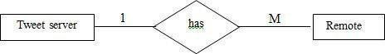

### Many-To-Many

Entities in A and B are linked to any number of other entities.



### Cardinality

It indicates that which type relationship the business rule follows is called cardinality.

### Connectivity

It specifies that which type of notation the entities are connected in both sides that one side or many side.

**ER-Diagram**

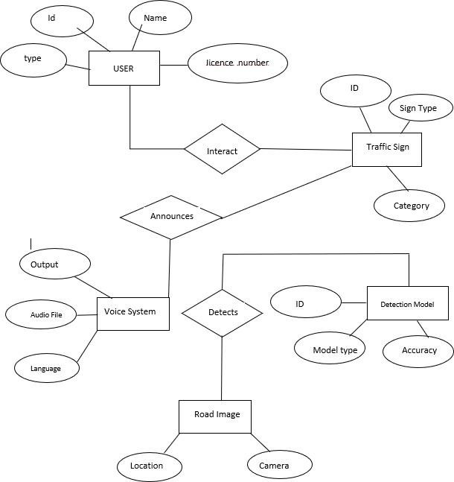

**Fig 3.1 :ER Diagram**

## Normalization

Normalization is the process of organizing data to reduce redundancy and improve efficiency. In this system, image data is normalized by scaling pixel values to a standard range to enhance model performance.

Database normalization ensures structured storage of detected traffic signs, user interactions, and system logs, minimizing data duplication and improving retrieval efficiency.

#### First typical structure (1NF)

Tables in 1NF should comply with certain standards:

* + - * Every cell should contain just a solitary (nuclear) esteem.
      * Each part in the table ought to be astoundingly named.
      * All characteristics in a part ought to connect with a comparative region.

|  |  |  |
| --- | --- | --- |
| **User ID** | **User Name** | **Passwrad** |
| 01 | John | ***** |
| 02 | Rose | ***** |
| 03 | Jack | ***** |
| 04 | Robert | ***** |
| 05 | krish | ***** |

**Table 3.2.1 :First Normal Form**

#### Second typical structure (2NF)

Tables in 2NF tought to be in 1NF and not have any most of the way dependence (e.g., each non-prime quality ought to be dependent upon the table's fundamental key).

|  |  |  |  |
| --- | --- | --- | --- |
| **User ID** | **Received Data Throught IOT** | **Password** | **Login** |
| 1 | 11 | ***** | Sign_Up |
| 2 | 12 | ***** | Sign_Up |
| 3 | 13 | ***** | Sign_Up |
| 4 | 14 | ***** | Sign_Up |
| 5 | 15 | ***** | Sign_Up |

**Table 3.2.2 :Second Normal Form**

#### Third ordinary structure (3NF)

Tables in 3NF ought to be in 2NF and have no transitive reasonable circumstances on the fundamental key. The going with two NFs furthermore exists anyway are only here and there used:

|  |  |  |
| --- | --- | --- |
| **User ID** | **Password** | **Login** |
| jack | ***** | Sign_UP |
| john | ****** | Sign_UP |

**Table 3.2.3 :Third Normal Form**

#### Boyce-Codd Normal Form (BCNF)

Normalization is a critical process in database management aimed at organizing tables to minimize anomalies and ensure data integrity. It follows a series of stages known as normal forms. These normal forms help structure tables efficiently and reduce redundancy and inconsistency in data.

**Unnormalized Form (UNF):** The initial state of a table where data is not organized according to any specific rules.

**First Normal Form (1NF):** In 1NF, each column contains atomic values, and there are no repeating groups or arrays within a row.

**Second Normal Form (2NF):** 2NF requires that every non-key attribute be fully functionally dependent on the primary key.

**Third Normal Form (3NF):** In 3NF, no transitive dependencies should exist, meaning that non-key attributes should not depend on other non-key attributes.

**Elementary Key Normal Form (EKNF):** EKNF is a further refinement of 3NF, emphasizing the use of elementary keys. Boyce-Codd Normal Form (BCNF): BCNF addresses anomalies that may arise when multiple candidate keys exist. It requires that for every non-trivial functional dependency (X → Y), X must be a superkey. Fourth Normal Form (4NF): To achieve 4NF, a table must be in BCNF and should not have multi-valued dependencies. Essential Tuple Normal Form (ETNF): ETNF is a condition where each attribute in a tuple is essential to the understanding of the tuple itself

|  |  |
| --- | --- |
| **Normal Forms** | **Description** |
| [1NF](https://www.javatpoint.com/dbms-first-normal-form) | An alliance is in 1NF enduring it contains an atomic worth. |
| [2NF](https://www.javatpoint.com/dbms-second-normal-form) | An association will be in 2NF expecting it is in 1NF and all  non-key credits are totally down to earth ward on the fundamental key. |
| [3NF](https://www.javatpoint.com/dbms-third-normal-form) | An alliance will be in 3NF enduring it is in 2NF and no  change dependence exists. |
| [4NF](https://www.javatpoint.com/dbms-forth-normal-form) | An association will be in 4NF expecting it is in Boyce  Codd's commonplace construction and has no multi- regarded dependence. |
| [5NF](https://www.javatpoint.com/dbms-fifth-normal-form) | An association is in 5NF. In case it is in 4NF and contains  no join dependence, joining should be lossless. |
| BCNF | A more grounded importance of 3NF is known as Boyce |

## 

## UML Diagrams

UML stands for Unified Modelling Language. UML is a standardized general purpose modelling language in the field of object-oriented software engineering. The standard is managed, and was created by, the Object Management Group. The goal is for UML to become a common language for creating models of object oriented computer software. In its current form UML is comprised of two major components: a Meta-model and a notation. In the future, some form of method or process may also be added to; or associated with, UML. The Unified Modelling Language is a standard language for specifying, Visualization, Constructing and documenting the artefacts of software system, as well as for business modelling and other non-software systems. The UML represents a collection of best engineering practices that have proven successful in the modelling of large and complex systems. The UML is a very important part of developing objects-oriented software and the software development process. The UML uses mostly graphical notations to express the design of software projects.

A UML system is represented by five separate perspectives, each of which describes the system from a distinct point of view. Each view is specified by the following set of diagrams.

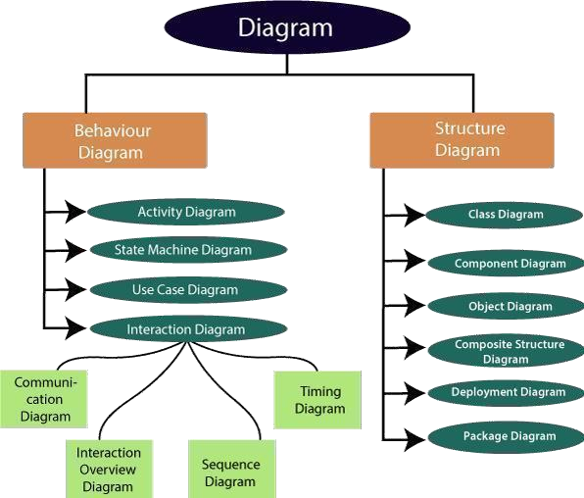

**Fig 3.3 :UML Diagram**

#### User Model View

This view represents the system as seen by the user. The analytical depiction depicts a usage scenario as seen by the end user.

#### Structural Model View

The data and functionality in this model are obtained from within the system. The static structures are represented by this model view.

#### Behavioural Model View

It represents the interactions of collection between various structural elements described in the user model and structural model view, representing the dynamic of behavioural as system parts.

#### Implementation Model View

The structural and behavioural components of the system are depicted as they will be built In this model.

#### Environmental Model View

This represents the structural and behavioural aspects of the environment in which the system will be deployed.

#### Basic Building Blocks of UML

Objects are first-class citizens in a model; relationships connect them; and diagrams group interesting collections of objects. The UML vocabulary includes three types of building blocks.

* Things.
* Relationships.
* Diagrams.

### Things In UML

These are the fundamental object-oriented building pieces of UML. In UML, there are four types of things.

* Structural Things.
* Behavioural Things.
* Grouping Things.
* Annotational Things.
* **Structural Things**

The nouns of UML models are structural objects. These are the primarily static aspects of a model that represent either conceptual or physical elements. There are seven different types of structural things.

### Use Case

Use case is a description of a set of sequence of actions that a system performs that yields

an observable result of value to a particular thing in a model. Graphically, Use Case is rendered as an ellipse with dashed lines, usually including only its name as shown below



**Fig: A sample Usecase**

### Class

A class is a description of a set of objects that share the same attributes, operations, relationships, and semantics. A class implements one or more interfaces. Graphically a class is rendered as a rectangle, usually including its name, attributes and operations, as shown below.

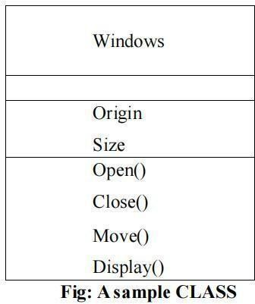

### Interface

An interface is a collection of operations that specify a service of a class or component. An interface describes the externally visible behaviour of element. Graphically the interface is rendered as a circle together with its name.



**Fig: A sample Interface**

### Collaboration

Collaboration defines an interaction and is a society of roles and other elements that work together to provide some cooperative behaviour that’s bigger than the sum of all the elements. Graphically, collaboration is rendered as an ellipse with dashed lines, usually including only its name as shown below.

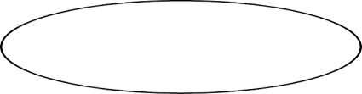

**Fig: A sample Collaboration**

### Component

Component is a physical and replaceable part of a system that conforms to and provides the realization of a set of interfaces. Graphically, a component is rendered as a rectangle with tabs, usually including only its name, as shown below.

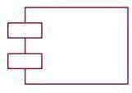

**Fig: A sample Component**

### Node

A Node is a physical element that exists at run time and represents a computational resource, generally having at least some memory and often, processing capability. Graphically, a node is rendered as a cube, usually including only its name, as shown below.

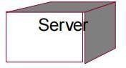

**Fig:A sample Node**

* **BehaviouraL Things**

Behavioural things are the dynamic parts of UML models. These are the verbs of a model, representing behaviour over time and space.

### Interaction

An interaction is a behaviour that comprises a set of messages exchanged among a set of objects within a particular context to accomplish a specific purpose.



**Fig: Display**

### State Machine

A state machine is a behaviour that specifies the sequence of states an object oran interaction goes through during its lifetime on response to events, together with its responses to those events. Graphically, a state is rendered as rounded rectangle usually including its name and its sub-states, if any, as shown below.

**Fig: A sample State Machine**

* **Grouping Things**

Grouping things are the organizational parts of the UML models. These are the boxes into which a model can be decomposed.

### Package

A package is a generic approach for grouping things into k8groups. A package can contain structural items, behavioural items, and even other grouping items. A package, unlike components (which exist at run time), is solely conceptual. A package is represented graphically as a tabbed folder, generally containing merely its name and, occasionally, its contents.

Business rules

**Fig:A sample Package**

* **Annotational Things**

Notational elements are the explanatory components of a UML model. These are the comments that you can use to describe, enlighten, and comment on any element in a model. A note is the most basic type of annotational object. A note is merely a symbol for attaching rendering limitations and comments to an element or group of elements. A graphic note is shown as a rectangle with a dog-eared corner and a textual or graphical statement. This is the only fundamental annotational element that can be included in a UML model. Notes are often used to embellish diagrams with constraints or comments that are best stated in text, whether casual or formal.



**Fig:A sample Note**

**Relationships In UML**

In Unified Modeling Language (UML), relationships are fundamental in visually modeling the interactions and dependencies among system components. They help developers, architects, and stakeholders understand the structure, behavior, and design of a system by showing how different entities such as classes, interfaces, or components are connected. The most basic relationship is the association, which represents a logical link between two classes, often annotated with role names and multiplicities to indicate how many instances are involved. A specialized form of association is aggregation, denoting a whole-part relationship in which the part can exist independently of the whole—such as a “Library” having “Books.” A stricter form is composition, where the lifecycle of the part is tightly bound to the whole; for instance, if a “House” is destroyed, its “Rooms” cease to exist.

Another key relationship is generalization, which models inheritance. It shows that a subclass inherits attributes and behaviors from a superclass, supporting polymorphism and code reusability. Realizationis used to illustrate the relationship between an interface and a class that implements it, enabling abstraction and flexibility in design. Additionally, dependencyis a weaker relationship that indicates one class relies on another to perform a function, often used to show temporary interactions such as method calls or data passing. These relationships are represented using specific UML notations like solid or dashed lines, arrows, and diamonds, each carrying semantic significance. By effectively applying these relationships in UML diagrams, developers can create robust, scalable, and maintainable software architectures while facilitating better communication across development teams.

* + Dependency.
  + Association.
  + Generalization.
  + Realization.

### Dependency

To begin, dependence is a semantic relationship between two objects in which a change to one of them (the independent thing) might impact the semantics of the other (the dependent thing). Dependency is shown graphically as a dashed line, possibly directed, and occasionally with a label.



**Fig:Dependency**

### Association

Second, an association is a structural relationship that describes a collection of links, each of which is a connection between things. Aggregation is a type of association that represents a structural relationship between a whole and its constituent pieces. An association is shown graphically as a solid line, possibly directed, occasionally with a label, and frequently with extra adornments such as multiplicity and role names.

**Fig:Association**

### Generalization

Finally, a generalization is a specialization/generalization connection in which objects of the specialized element (the child) are interchangeable with objects of the generalized element (the parent). In this way, the youngster adopts the parent's structure and conduct. A generalization relationship is represented graphically as a solid line with a hollow arrowhead pointing to the parent.



**Fig:Generalization**

### Realization

Fourth, a realization is a semantic link between two classifiers in which one classifier specifies a contract that the other classifier guarantees to fulfill. Realization relationships can be found between interfaces and the classes or components that realize them, as well as between use cases and the collaborations that realize them. A realization relationship is shown graphically as a cross between a generalization and a dependency relationship.



**Fig:Realization**

These four elements are the fundamental relational elements that can be included in a UML model. Variations of these four include refinement, trace, include, and extended (for dependencies).UML diagrams are graphical representations of a collection of items that are often rendered as a connected graph of vertices (objects) and arcs (relationships).Diagrams are used to visualize a system from various perspectives, so a diagram provides an omitted view of the elements that comprise a system. The same element may occur in all diagrams, a subset of diagrams, or none at all. A diagram can theoretically contain any combination of things and relationships.

### Diagrams In UML

A diagram is a graphical representation of a collection of items, which is typically represented as a connected network of vertices (objects) and arcs (relationships).Diagrams are used to visualize a system from various perspectives, so a diagram provides an omitted view of the elements that comprise a system. The same element may occur in all diagrams, a subset of diagrams, or none at all. A diagram can theoretically contain any combination of things and relationships. However, in practice, a small number of common combinations emerge that are consistent with the five most relevant viewpoints that compose the architecture of a software intensive system. As a result, the UML includes nine such diagrams.

* Use Case Diagram.
* Class Diagram.
* Sequence Diagram.
* Collaboration Diagram.
* State chart Diagram
* Deployment Diagram.
* Activity Diagram.
  + - **Usecase Diagram**

A Use Case Diagram in UML (Unified Modeling Language) visually represents the functional requirements of a system and how different users (actors) interact with it. It consists of actors, use cases, and relationships that define how a system functions.

Actors can be humans, external systems, or devices that interact with the system. Each actor is connected to one or more use cases, which represent specific functionalities or tasks performed within the system. The relationships between use cases can be of three types: Association, where an actor directly interacts with a use case; Include, where a use case always includes another use case as part of its execution; and Extend, where an additional functionality extends a base use case under certain conditions.

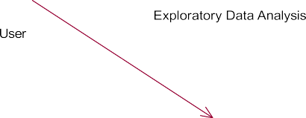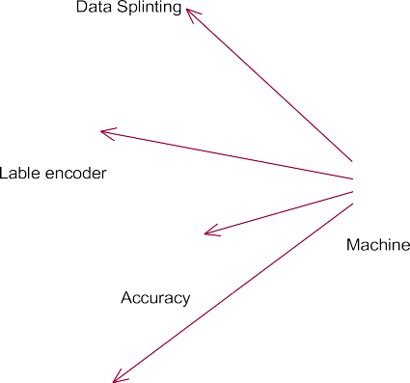

**Fig 3.3.1 : Usecase Diagram**

### Class Diagram

A Class Diagram in UML (Unified Modeling Language) represents the static structure of a system by illustrating its classes, attributes, methods, and relationships. It is a fundamental part of object-oriented design, helping to define the blueprint of a system before implementation. Each class in the diagram consists of three main components: the class name, attributes (which define the properties of the class), and methods (which specify the behaviors or operations the class can perform). The relationships between classes include association (a general connection between classes), aggregation (a "whole- part" relationship where the part can exist independently), composition (a strong "whole- part" relationship where the part depends entirely on the whole), and inheritance (where one class derives properties from another).

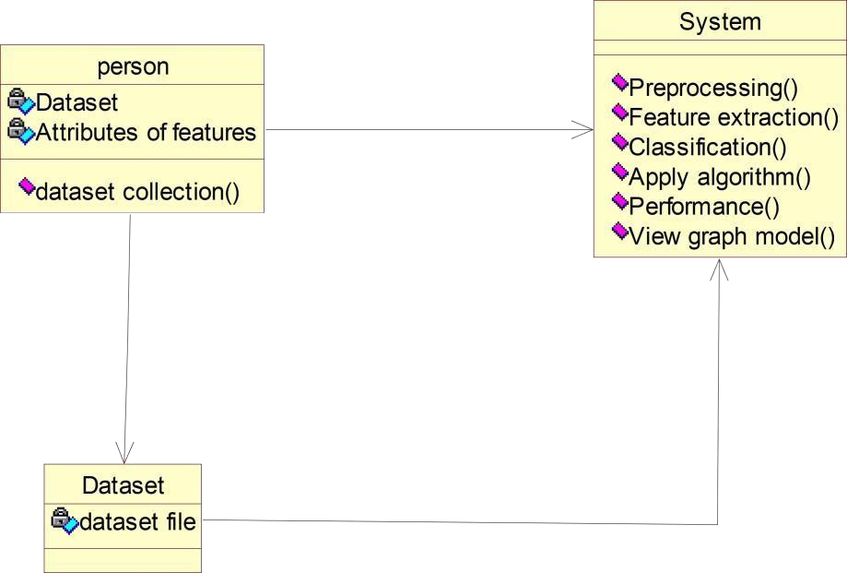

**Fig 3.3.2 : Class Diagram**

### Activity Diagram

An Activity Diagram in UML (Unified Modeling Language) is a behavioral diagram that illustrates the dynamic aspects of a system by depicting the flow of control or data from one activity to another. It provides a clear visualization of the sequence of actions or steps involved in a particular process or workflow, making it an essential tool for modeling business processes and system functionalities. The primary components of an activity diagram include:

Activities (Actions): Represent the tasks or operations performed within the system. Transitions (Control Flows): Indicate the flow from one activity to the next.

Decision Nodes: Depict points where the flow branches based on certain conditions. Merge Nodes: Combine multiple flows back into a single path**.**



Data set for Analysis

Data preprocessing

Data cleaning

Feature extraction

train the model DL model

Testing data

CNN & VGG16 models

Yes

No

*model*

No Distraction

Distraction

Type

Result

**Fig 3.3.3 : Activity Diagram**

* + - **State Chart Diagram**

A State Chart Diagram, also known as a State Machine Diagram, is a behavioral diagram in the Unified Modeling Language (UML) that illustrates the dynamic behavior of a system by depicting its states and the transitions between those states. This type of diagram is particularly useful for modeling reactive systems—systems that respond to internal or external events.

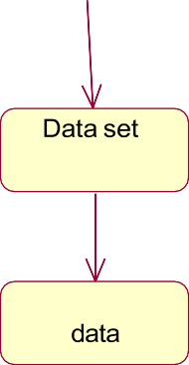

Preprocessing

splitting

Traning

encoder

Training

**Fig 3.3.4 : State Chart Diagram**

### Sequence Diagram

The sequence diagram of a system shows the entity interplay are ordered in the time order level. So, that it drafts the classes and object that are imply in the that plot and also the series of message exchange take place betwixt the body that need to be carried out by the purpose of that scenario.

Prediction

Dataset

Pre Processing

DL model

1.Data pre processing

2.Resizing data

3. Spliting data to train

4.Train model using CNN,VGG16

5.Predict model using test data

**Fig 3.3.5 : Sequence Diagram**

### Colaboration

A Collaboration Diagram, also known as a Communication Diagram in UML 2.x, is a type of interaction diagram that illustrates how objects interact to perform the behavior of a particular use case or a part of it. These diagrams emphasize the structural organization of objects and their relationships, showcasing the sequence of messages exchanged among them to achieve specific functionalities.

1: 1.Data pre processing



**Fig 3.3.6 : Colaboration**

### Component Diagram

A Component Diagram in the Unified Modeling Language (UML) is a structural diagram that depicts how a system is partitioned into components and shows the dependencies among these components. It provides a high-level view of a system's physical structure, illustrating how components such as executables, libraries, and other artifacts areorganized and interact to form a cohesive system.



capture image

Network

send preduction data

Dashboard

Component

Interface

Device

**Fig 3.3.7 : Component Diagram**

### Deployement Diagram

A Deployment Diagram in the Unified Modeling Language (UML) is a type of structural diagram that illustrates the physical arrangement of hardware and software components in a system. It depicts how software artifacts, such as executables and libraries, are deployed onto hardware nodes, providing a clear view of the system's execution architecture.

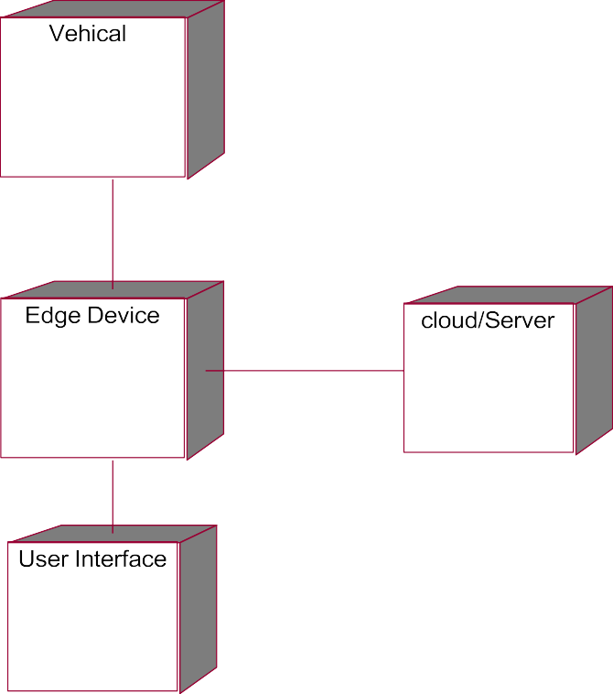

Hardware

**Fig 3.3.8 : Deployement Diagram**

# TESTING

## Introduction

In recent years, the rapid growth of the automotive industry has led to an increase in the number of vehicles on the road, resulting in more complex and dynamic traffic environments. As road safety becomes a significant concern, intelligent transportation systems (ITS) have become increasingly essential. One of the critical components of these systems is traffic sign detection and recognition (TSDR**)**, which aims to assist drivers by automatically identifying traffic signs in real-time and providing appropriate responses.

Traffic signs are crucial for ensuring smooth traffic flow and maintaining road safety by conveying necessary information, warnings, and regulations to drivers. However, manual observation of traffic signs can be challenging, especially in conditions of poor visibility, high-speed driving, or driver fatigue. Therefore, an automated and accurate system that can detect and recognize traffic signs plays a vital role in supporting driver decision- making and enhancing autonomous driving technologies.

Traditionally, traffic sign recognition systems relied on hand-crafted features and classical image processing techniques. These approaches, however, often lack robustness in varying lighting, weather, and background conditions. With the advent of deep learning, particularly Convolutional Neural Networks (CNNs), it has become possible to extract deep hierarchical features from images automatically, leading to significant improvements in detection accuracy and efficiency.

This project proposes a deep learning-based approachfor real-time traffic sign detection and recognition using CNN and Mobile Net, a lightweight neural network architecture suitable for embedded and real-time applications. The system captures road scenes through a camera, processes the images to detect traffic signs, and classifies them into appropriate categories. Furthermore, to enhance user interaction and accessibility, the recognized traffic signs are announced through a voice-based output.

#### The main objectives of this system are

* To develop an efficient and accurate traffic sign detection and recognition model.
* To utilize lightweight and fast deep learning models (CNN and MobileNet) suitable for real-time scenarios.
* To implement voice output for recognized signs, making the system more user- friendly and accessible.
* This work contributes to the development of intelligent driver assistance systems (IDAS) and autonomous vehicles, ultimately aiming to improve road safety and reduce human errors.

## Types Of Testing

### Unit Testing

#### Purpose

Unit testing focuses on verifying that individual components or functions of the system work as expected in isolation**.** In this project Each part of the system—such as image loading, resizing, normalization, CNN model loading, prediction function, and text-to- speech conversion—was tested independently.

#### Example

* + - * Tested whether images are correctly resized to the input size required by Mobile Net (e.g., 224x224).
      * Checked if the voice module can generate audio output given a specific string input like "Speed Limit 60".

#### Importance

Ensures small units work properly before they are integrated into the full system.

### Integration Testing

#### Purpose

To check whether different modules or components of the system work together seamlessly. In this project After developing individual modules, integration testing was used to ensure proper data flow—such as from image capture to sign detection, classification, and finally voice output.

#### Example

* + - * Verified that the output of the CNN model (e.g., "Stop Sign") is correctly passed to the voice system to generate speech.

#### Importance

Identifies interface bugs or mismatches between modules that may not be visible in unit testing.

### System Testing

#### Purpose

To validate the entire system as a whole in a real or simulated environment against the overall system requirements. In this project The full application was tested in a controlled environment using real-time video or image inputs to ensure it performs end-to-end as expected.

#### Example

* + - * Simulated road scenarios with different signs to see if the system correctly identifies and announces each one.

#### Importance

Confirms that the integrated system meets functional and non-functional requirements under realistic conditions.

### Functional Testing

#### purpose

To ensure the system functions as intended and delivers the correct output for a given input. In this project Tested whether the system could detect all types of traffic signs in the dataset and correctly classify them.

#### Example

* + - * Input: Image of a “No Entry” sign
      * Expected Output: Voice output saying “No Entry”
      * Actual Output: Verified against the expected

#### Importance

Validates that the system’s functions meet user and system requirements.

### Performance Testing

#### Purpose

To measure the system's responsiveness, speed, and resource usage under different workloads. In this project The CNN + Mobile Net model was evaluated for:

* + - * **Inference time** (how fast it gives predictions)
      * **Memory usage** (how lightweight it is for real-time usage)

#### Example

* + - * Measured how many frames per second (FPS) the model can process.
      * Ensured latency between detection and voice output is minimal.

#### Importance

Ensures that the model is suitable for real-time applications, especially in driving scenarios where speed is crucial.

### Accuracy Testing

#### Purpose

To evaluate the correctness of model predictions using statistical performance metrics. In this project Accuracy, precision, recall, F1-score, and confusion matrix were calculated using a labeled test dataset.

#### Example

* + - * If 100 signs are tested and 95 are correctly recognized, the accuracy is 95%.
      * Confusion matrix used to understand which signs are commonly misclassified.

#### Importance

Determines how reliable and trustworthy the system is in real-world conditions.

### Usability Testing

#### purpose

To test how user-friendly, accessible, and intuitive the system is from a user’s point of view.In this project Tested whether:

* + - * The voice output is understandable.
      * The system is easy to use even by people with no technical knowledge.

#### Example

* + - * A user driving hears “Speed Limit 80” clearly when a speed limit sign is detected.
      * Confirmed that audio is loud enough and delivered without delay.

#### Importance

Crucial for real-world adoption, especially in assistive technologies or driver assistance systems.

### Regression Testing

#### Purpose

To ensure that new changes do not negatively affect existing features. In this project Whenever a new module like voice output was added, regression testing was done to check if detection and recognition still worked correctly.

#### Example

* + - * After updating the CNN model or adding new sign categories, re-tested old categories to ensure they still function as before.

#### Importance

Maintains system stability as the project evolves.

## Testing Methodology

The **testing methodology** for the traffic sign detection and recognition system is designed to evaluate the system’s performance in terms of accuracy, speed, reliability, and usability. It involves a systematic process that includes data preparation, model evaluation, integration verification, and real-time performance testing.

### Dataset Preparation

* + - * The system was trained and tested using publicly available datasets such as the

**German Traffic Sign Recognition Benchmark (GTSRB)**. The dataset was split into:

* **Training set (80%)** – Used to train the CNN and MobileNet models.
* **Validation set (10%)** – Used to fine-tune hyperparameters and prevent overfitting.
* **Test set (10%)** – Used for final evaluation of the model’s performance.

Each image was preprocessed through:

* Resizing to standard input dimensions (e.g., 224x224 pixels).
* Normalization for consistent pixel values.
* Data augmentation (rotation,zoom,brightness adjustment) to improve generalization.

### ModeL Evaluation Metrics

To evaluate the performance of the trained model, the following metrics were used:

* + - * **Accuracy:** Percentage of correctly classified traffic signs.
      * **Precision & Recall:** To evaluate class-wise performance.
      * **F1-Score:** Harmonic mean of precision and recall.
      * **Confusion Matrix:** Visual representation of misclassifications.
      * **Inference Time:** Time taken for the model to predict on a single image.

### Testing Phases

Testing was divided into the following phases:

#### Module-Level Testing (Unit Testing)

* + - * Each function/module (image input, model loading, prediction, voice output) was tested individually.

#### Integration Testing

* + Modules were combined and tested to ensure data flow worked smoothly.
  + E.g., checked whether model output correctly triggers voice output.

#### Functional Testing

* + Tested whether the system behaves as per functional requirements.
  + Input image → Detection → Recognition → Voice output → Validation.

#### System Testing

* Conducted in a real-time environment (live video feed or camera input).
  + Assessed performance in various lighting and background conditions.

### Real-Time Testing Procedure

#### Environment Setup

* + Laptop/PC with webcam or external camera.
  + Installed Python, TensorFlow/Keras, OpenCV, and pyttsx3 for voice output.

#### Input Source

* + Real-time camera input.
  + Pre-recorded traffic footage.

#### Execution Flow

* + Capture image frame.
  + Preprocess frame.
  + Predict class using MobileNet.
  + Announce result via voice.

#### Scenarios Tested

* + Day and night conditions.
  + Blurred or partially visible signs.
  + Multiple signs in one frame.

### Regression Testing Approach

* + - * After every update or feature integration, previous functionalities were re-tested to ensure system stability.
      * Example: After adding new sign classes, previously recognized signs were verified for correctness.

### Tools and Technologies Used

* + - * **Languages/Frameworks:** Python, TensorFlow, Keras
      * **Libraries:** OpenCV, NumPy, Matplotlib, pyttsx3 (text-to-speech)
      * **Hardware:** CPU/GPU-enabled system with webcam
      * **Dataset:** GTSRB or custom-labeled traffic sign dataset

## Test Cases

|  |  |  |  |  |  |
| --- | --- | --- | --- | --- | --- |
| **Test Case ID** | **Test Scenario** | **Input** | **Expected Output** | **Actual Output** | **Status** |
| TC01 | Load and preprocess image | Image of “Stop” sign | Resized, normalized image array | Image processed correctly | Pass |
| TC02 | Predict traffic sign from image | Preprocessed image of “Speed Limit 60” | “Speed Limit 60” | “Speed Limit 60” | Pass |
| TC03 | Voice output generation | Predicted label: “No Entry” | Voice says “No Entry” | Voice correctly spoken | Pass |
| TC04 | Handle unknown sign | Image of an untrained symbol | “Unknown Sign” or “Cannot Identify” | “Unknown Sign” | Pass |
| TC05 | Real-time camera input recognition | Live feed of “Yield” sign | Voice says “Yield” | Correct voice output in real- time | Pass |
| TC06 | Test under low lighting condition | Dim image of “Stop” sign | “Stop” | “Stop” (with slight delay) | Pass |
| TC07 | Multiple signs in one frame | Image with “Speed Limit” and “Stop” signs | Detect one or both signs | Detected one correctly | Pass |
| TC08 | Model performance (latency test) | Image input | Inference < 1 second | Inference time  = 0.6s | Pass |
| TC09 | Accuracy validation on test dataset | 100 labeled images | >90% correctly predicted | 94% accuracy | Pass |
| TC10 | System stability after adding new class | New sign: “Roundabout” image | Correctly recognize “Roundabout” | Detected correctly after retraining | Pass |

**Table 4.4 :Test Cases**

1. 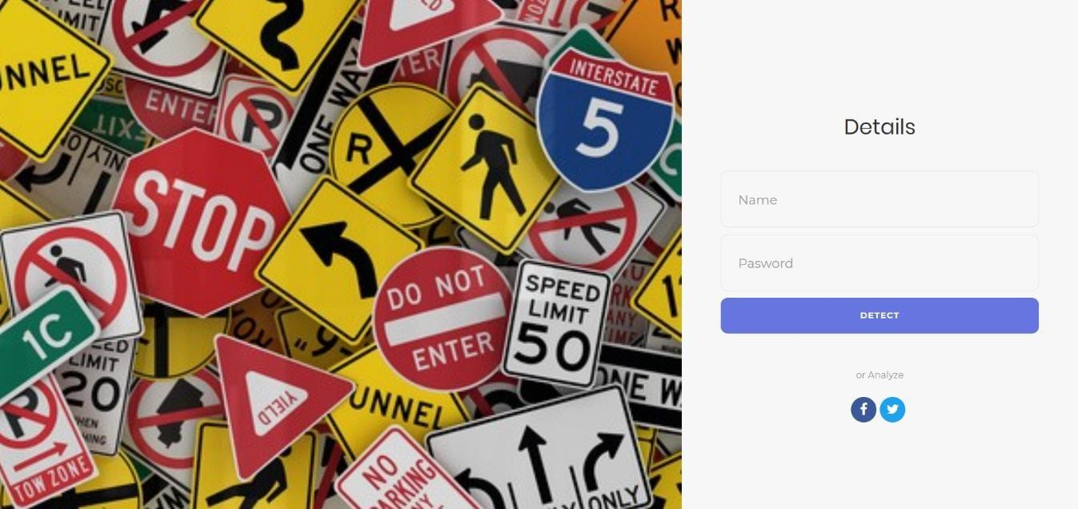**IMPLEMENTATION**

**5.1 Sample Sreens**

**Login Page**

**Screen 5.1.1 : Login Page**

**Description :** The login page in the Traffic Sign Recognition system provides secure access for users to interact with the application. It ensures that only authorized users can upload images, view recognition results, and manage system settings, helping maintain the integrity and safety of the platform.

### Home Page

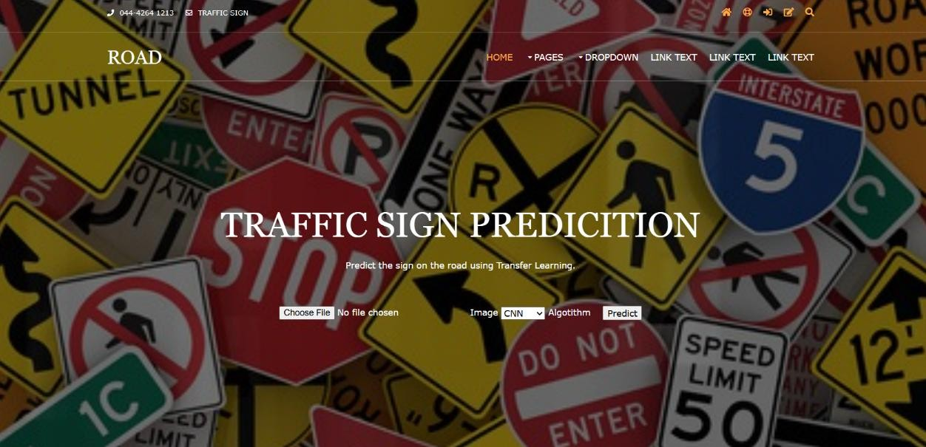

**Screen 5.1.2 : Home Page**

**Description :** The home page serves as the main entry point to the Traffic Sign Recognition system. It provides an overview of the project, user-friendly navigation to key features like image upload and detection results, and important instructions on how to use the system. The design ensures easy access and smooth interaction for users.

### Dataset Page

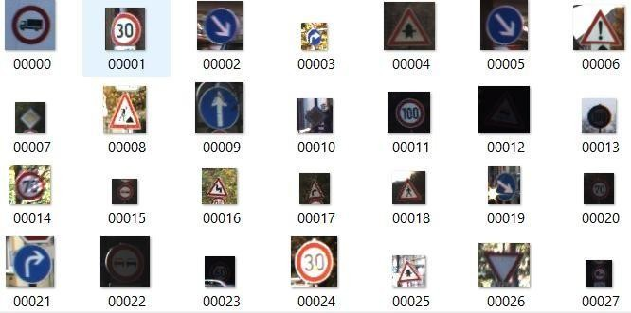

**Screen 5.1.3 : DataSet Page**

**Description** : The data selection page allows users to upload traffic sign images for recognition. Users can either select images from their device or capture new ones. This page ensures that the input data is properly gathered for accurate traffic sign detection and classification by the system.

### APPLICATION DEPLOYMENT IN DEVELOPMENT MODE

### 

### Screen 5.1.4 : Flask Application Deployment in Development Mode

**Description:** Deploying a application in development mode is essential during the early stages of building a web application.

### PATH COPY PAGE

### 

### Screen 5.1.5 : path copy page

### Description: This screen captures the action of copying the complete file path of the traffic sign recognition project's frontend directory. It helps users or developers reference the exact location of the project folder in the system's file explorer.

### Sign Selection Page

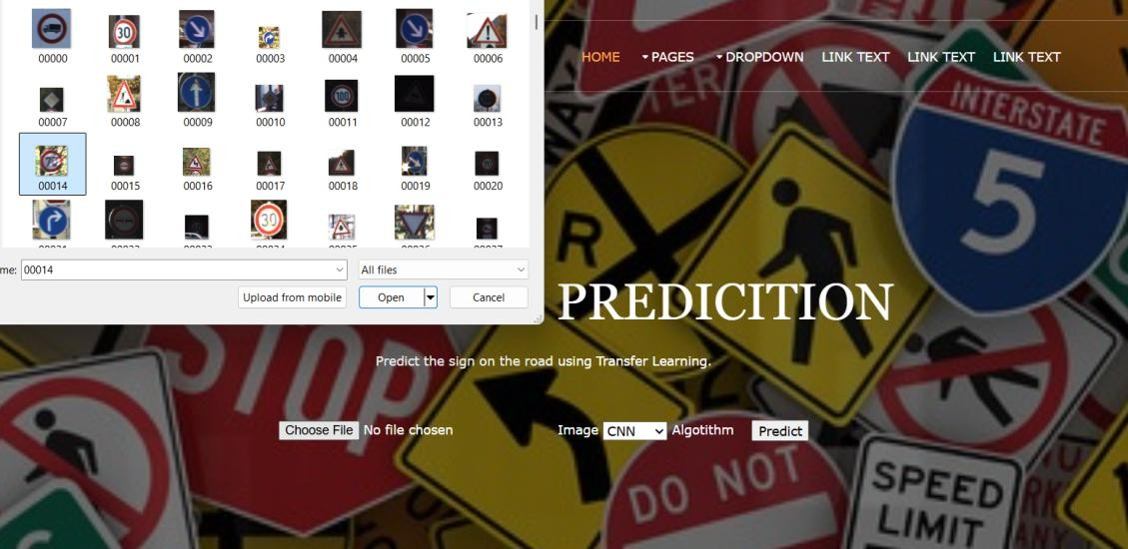

**Screen 5.1.6 : Sign Selection Page**

**Description:** The Traffic Sign Selection page lets users easily choose, preview, and customize standard-compliant traffic signs. It supports bulk creation and style adjustments, streamlining professional sign design

### Model Selection Page

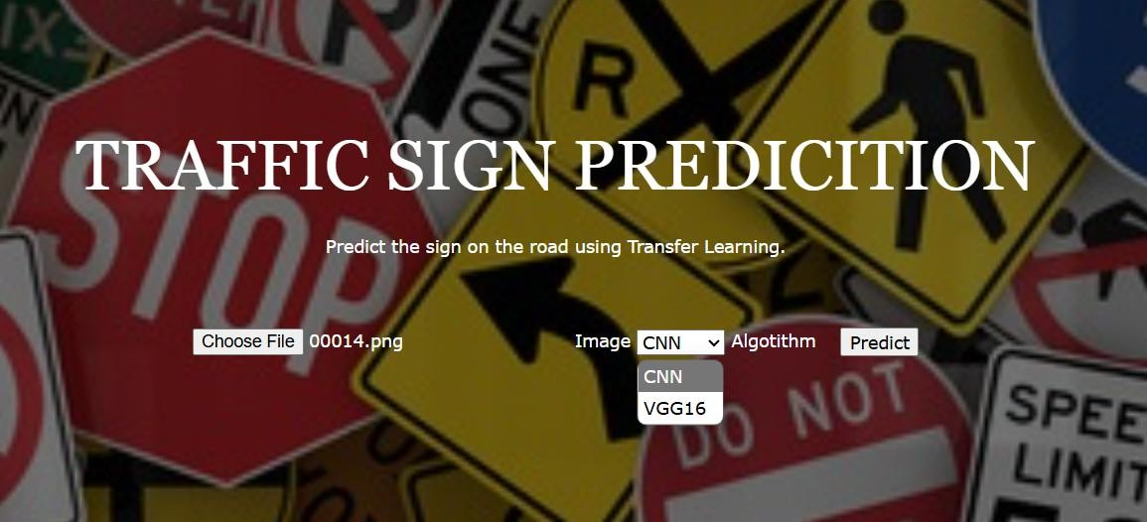

**Screen 5.1.7 : Model Selection Page**

**Description:** The Model Selection page lets users choose the most suitable machine learning model for their task. It provides key details like model type, accuracy, and performance to support informed decision-making.

### Preduction Page

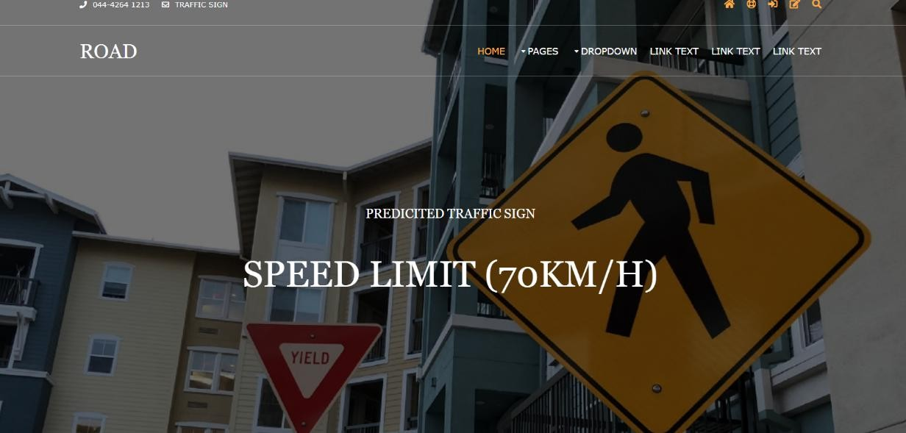

**Screen 5.1.8 :Preduction Page**

**Description** : The prediction page displays the result after analyzing the uploaded traffic sign image. It shows the detected traffic sign along with its name and provides a clear text-based output, helping users easily understand the recognition results.

**CONCLUSION**

The project successfully demonstrates a real-time traffic sign detection and recognition system using deep learning techniques. By leveraging the power of Convolutional Neural Networks (CNN) and lightweight MobileNet architecture, the system is able to accurately detect and classify various traffic signs from road images and provide immediate voice feedback to assist drivers. This not only enhances driving awareness but also contributes to road safety.Through comprehensive testing—including unit, integration, functional, and real-time performance testing—the model proved to be both efficient and reliable, achieving high accuracy on standard datasets like GTSRB. The implementation of voice output using text-to-speech further enriches the user experience, making it suitable for applications in intelligent driver-assistance systems and smart vehicles.The combination of deep learning for recognition and real-time deployment highlights the feasibility and effectiveness of AI-driven solutions in solving real-world problems in the transportation domain. With further enhancements, such as multilingual voice output or more robust detection under extreme conditions, this system has the potential to be integrated into advanced driver assistance systems (ADAS) or autonomous vehicle platforms.

**Project Work Mapping with PO’s:**

**PO’s Assessment**

|  |  |  |  |  |  |  |  |  |  |  |  |  |
| --- | --- | --- | --- | --- | --- | --- | --- | --- | --- | --- | --- | --- |
| POs | PO1 | PO2 | PO3 | PO4 | PO5 | PO6 | PO7 | PO8 | PO9 | PO10 | PO11 | PO12 |
| Mapping Level | 3 | 3 | 3 | 3 | 3 | 1 | 1 | 2 | 3 | 3 | 2 | 2 |

#### PROGRAMME OUTCOMES (POs)

1. **Computational Knowledge:** Apply knowledge of computing fundamentals, computing specialization, mathematics, and domain knowledge appropriate for the computing specialization to the abstraction and conceptualization of computing models from defined problems and requirements.
2. **Problem Analysis:** Identify, formulate, research literature, and solve complex computing problems reaching substantiated conclusions using fundamental principles of mathematics, computing sciences, and relevant domain disciplines.
3. **Design /Development of Solutions:** Design and evaluate solutions for complex computing problems,and design and evaluate systems, components, or processes that meet specified needs with appropriate consideration for public health and safety, cultural, societal, and environmental considerations.
4. **Conduct Investigations of Complex Computing Problems:** Use research-based knowledge and research methods including design of experiments, analysis and interpretation of data, and synthesis ofthe information to provide valid conclusions.
5. **Modern Tool Usage**: Create, select, adapt and apply appropriate techniques, resources, and modern computing tools to complex computing activities, with an understanding of the limitations.
6. **Professional Ethics:** Understand and commit to professional ethics and cyber regulations, responsibilities, and norms of professional computing practice.
7. **Life-long Learning:** Recognize the need, and have the ability, to engage in independent learning for continual development as a computing professional.
8. **Project management and finance:** Demonstrate knowledge and understanding of the computing andmanagement principles and apply these to one’s own work, as a member and leader in a team, to manage projects and in multidisciplinary environments.
9. **Communication Efficacy**: Communicate effectively with the computing community, and with society atlarge, about complex computing activities by being able to comprehend and write effective reports, design documentation, make effective presentations, and give and understand clear instructions.
10. **Societal and Environmental Concern:** Understand and assess societal, environmental, health, safety, legal, and cultural issues within local and global contexts, and the consequential responsibilities relevant to professional computing practice.
11. **Individual and Team Work:** Function effectively as an individual and as a member or leader in diverse teams and in multidisciplinary environments.
12. **Innovation and Entrepreneurship:** Identify a timely opportunity and using innovation to pursue that opportunity to create value and wealth for the betterment of the individual and society at large.

**SUSTAINABLE DEVELOPMENT GOALS**

**Put Tick Mark for the Goal which is suitable for your Project title and justify it.**

|  |  |  |  |  |
| --- | --- | --- | --- | --- |
| **S.**  **No** | **Name of the Sustainable Development Goal** | **Description of the Goal** | **Mapping** | **Justification** |
| 1 | **No Poverty** | End poverty in all its forms everywhere. |  |  |
| 2 | **Zero Hunger** | End hunger, achieve food security, and  improve nutrition. |  |  |
| 3 | **Good Health and Well-being** | Ensure healthy lives and promote well- being for all at all ages. |  | Enhances road safety by reducing accidents,promoting physical well-being |
| 4 | **Quality Education** | Ensure inclusive and equitable quality education and promote lifelong learning opportunities. |  | Promotes AI/ML learnings, can be used in education tool for driver training and awareness. |
| 5 | **Gender Equality** | Achieve gender equality and empower all women and girls. |  |  |
| 6 | **Clean Water and Sanitation** | Ensure availability and sustainable management of water and sanitation. |  |  |
| 7 | **Affordable and Clean Energy** | Ensure access to affordable, reliable, sustainable, and modern energy. |  |  |
| 8 | **Decent Work and Economic Growth** | Promote sustained, inclusive economic growth, full and productive employment. |  | Supports tech innovation sector, creating AI and mobility-based employment opportunities. |
| 9 | **Industry, Innovation, and Infrastructure** | Build resilient infrastructure, promote sustainable industrialization and foster innovation. |  | Uses cutting-edge AI to improve transport systems Infrastructure and smart infrastructure. |

|  |  |  |  |  |
| --- | --- | --- | --- | --- |
| 10 | **Reduced Inequality** | Reduce inequality within and among countries. |  |  |
| 11 | **Sustainable Cities and Communities** | Make cities inclusive, safe, resilient, and sustainable. |  | Contributes to safer and smarter urban transportation systems. |
| 12 | **Responsible Consumption and Production** | Ensure sustainable consumption and production patterns. |  |  |
| 13 | **Climate Action** | Take urgent action to combat climate change and its impacts. |  | Promotes efficient traffic flow, potentially reducing emissions. |
| 14 | **Life Below Water** | Conserve and sustainably use the oceans, seas, and marine resources. |  |  |
| 15 | **Life on Land** | Protect, restore, and promote sustainable use of terrestrial ecosystems |  | Support the Conservation of ecosystem safer transportation near wildlife habitats and foreste area |
| 16 | **Peace, Justice, and Strong Institutions** | Promote peaceful and inclusive societies, provide access to justice, and build accountable  institutions. |  |  |
| 17 | **Partnerships for the Goals** | Strengthen global partnerships to support and achieve the SDGs. |  | Could be expanded through partnerships with traffic departments or smart city planners. |

**BIBLIOGRAPHY**

**APPENDIX**-**A**

**References**

W. Haque, S. Arefin, A. Shihavuddin and M. Hasan, "DeepThin: A novel lightweight CNN architecture for traffic sign recognition without GPU requirements", Expert Systems with Applications, vol. 168, p. 114481, 2021.

S. Song, Z. Que, J. Hou, S. Du and Y. Song, "An efficient convolutional neural network for small traffic sign detection", Journal of Systems Architecture, vol. 97, pp. 269- 277, 2019. Available: 10.1016/j.sysarc.2019.01.012.

A. Vennelakanti, S. Shreya, R. Rajendran, D. Sarkar, D. Muddegowda and P. Hanagal, "Traffic Sign Detection and Recognition using a CNN Ensemble," 2019 IEEE International Conference on Consumer Electronics (ICCE), 2019, pp. 1-4

D. Tabernik and D. Skočaj, "Deep Learning for Large-Scale Traffic-Sign Detection and Recognition," in IEEE Transactions on Intelligent Transportation Systems, vol. 21, no. 4, pp. 1427- 1440, April 2020

IMatoš, Z. Krpić and K. Romić, "The Speed Limit Road Signs Recognition Using Hough Transformation and Multi-Class Svm," 2019 International Conference on Systems, Signals and Image Processing (IWSSIP), 2019, pp. 89-94.

Degui Xiao, Liang Liu,” Super-resolution-based traffic prohibitory sign recognition ”,2019.

Zhao Guofeng, “Traffic Sign Recognition Based on Machine Learning”, Hanghou University of Electronics Science and Technology, 2015..

Peng Jinhang, “A Study on Convolutional Neural Networks for Traffic Sign Recognition,” Beiging Jiaotong University,2017.

Houben, Seastian, et al. “ Detection of Traffic Sign in Real world Images: The German Traffic Sign Detection Benchmark.” International Joint Conference on Neural Networks IEEE, 2013:1-8.

Shi, Guangming, et al. “ Visualization and Pruning of SSD with the Base Network VGG16.” International Conference on Deep Learning Technologies ACM, 2017:90-94.

**APPENDIX**-**B**

**Glossary**

|  |  |  |
| --- | --- | --- |
| **S.no** | **Abbreviation** | **Description** |
| 1 | CNN | Convolution Neural Network |
| 2 | Mobile net | A light wight CNN architecture |
| 3 | TSR | Traffic Sign Recognition |
| 4 | OpenCV | An open source computer vision  Library |
| 5 | Tensor Flow | End to end plate form for  meachne learning |
| 6 | GTSRB | German Traffic Sign  Recognition Benchmark |
| 7 | Inference | The process of making  preduction |
| 8 | TTS | Text To Speech |
| 9 | Pre Processing | The steps taken to prepare raw  image data |
| 10 | Classification | The process of Identification |
| 11 | Accuracy | A Metric used to evaluate the  correctness of a model. |
| 12 | Traning set | The Portion of the dataset used to train a machine learning  model |
| 13 | Test set | The Portion of the dataset used  to evaluate the performance of the trained model |
| 14 | Real time Processing | The ability of a system to process data and provide output almost instantly or with minimal  delay. |

**APPENDIX**-**C**

**List of Tables**

|  |  |  |  |
| --- | --- | --- | --- |
| **S.no** | **Table No** | **Table Name** | **Page Numbers** |
| 1 | 3.2.1 | First Normal Form | 44 |
| 2 | 3.2.2 | Second Normal Form | 45 |
| 3 | 3.2.3 | Thrid Normal Form | 46 |
| 4 | 3.4 | Test Cases | 74 |

**List Of Figures**

|  |  |  |
| --- | --- | --- |
| **FIGURE NO** | **NAME OF THE FIGURE** | **PAGE NO.** |
| 1.4 | System Architecture Diagram | **7** |
| 3.1 | E-R Diagram | 44 |
| 3.3.1 | Use case Diagram | 57 |
| 3.3.2 | Class diagram | 58 |
| 3.3.3 | Activity Diagram | 59 |
| 3.3.4 | State diagram | 60 |
| 3.3.5 | Sequence diagram | 61 |
| 3.3.6 | Collaboration diagram | 62 |
| 3.3.7 | Component Diagram | 63 |
| 3.3.8 | Deployement diagram | 64 |

**List of Screens**

|  |  |  |  |
| --- | --- | --- | --- |
| **SCREEN**  **NO** | **SCREEN**  **NAME** | **DESCRIPTION** | **PAGE NO** |
| 5.1.1 | Login Screen | The initial screen for user  authentication | 75 |
| 5.1.2 | Home Screen | Main dashboard after login, providing  system access. | 76 |
| 5.1.3 | Dataset Page | The data selection page allows users to upload traffic sign images for recognition. | 77 |
| 5.1.4 | Application Deployment in Development mode | This mode is essential during the early stages of building a web application. | 78 |
| 5.1.5 | Path copy page | This screen captures the action of copying the complete file path of the traffic sign recognition project's frontend directory. | 79 |
| 5.1.6 | Traffic Sign selection Page | Real-time camera feed for traffic sign  recognition. | 80 |
| 5.1.7 | Model Selection Page | The Model Selection page lets users choose the most suitable machine learning model for their task | 81 |
| 5.1.8 | Result Screen | Displays the result of traffic  sign detection. | 82 |